**Jenkins – Day-03 Jenkins Clone, SonarQube Integration**

Task: Create one jenkins job using the below code and create three stages

Stage1: Git clone to download the source code.

Stage2: Sonarqube Integration to check the quality of code.

Stage3: Slack Integration to send the alerts to slack.

Launch an instance with following configs hostname

'Master-Jenkins-Server’ > AMI HVM2 > t2.medium > VPC – default > Subnet us-east-1a > Enable Auto-Assign

IP > SG - default i.e all ports are opened > Storage -30GB >

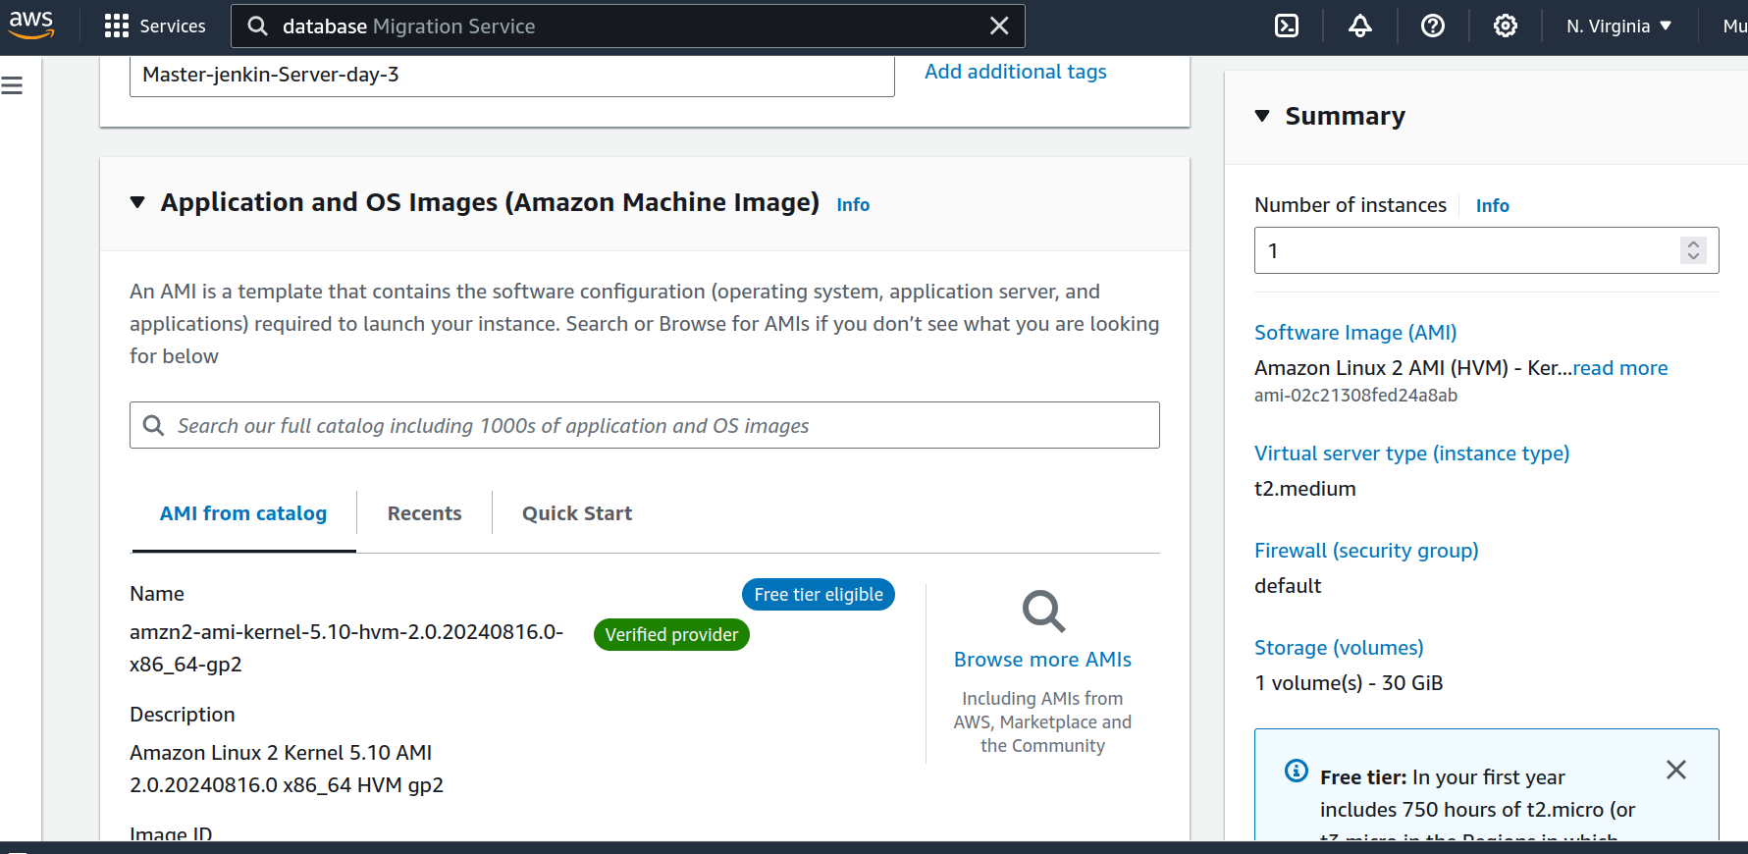  
http://44.210.129.82:8080/

Secure the jenkins server by changing password from user > configure > pass create and delete from cli. Create a new job: DashB > New item > Development-infr-depl > add shared repo of code/app.

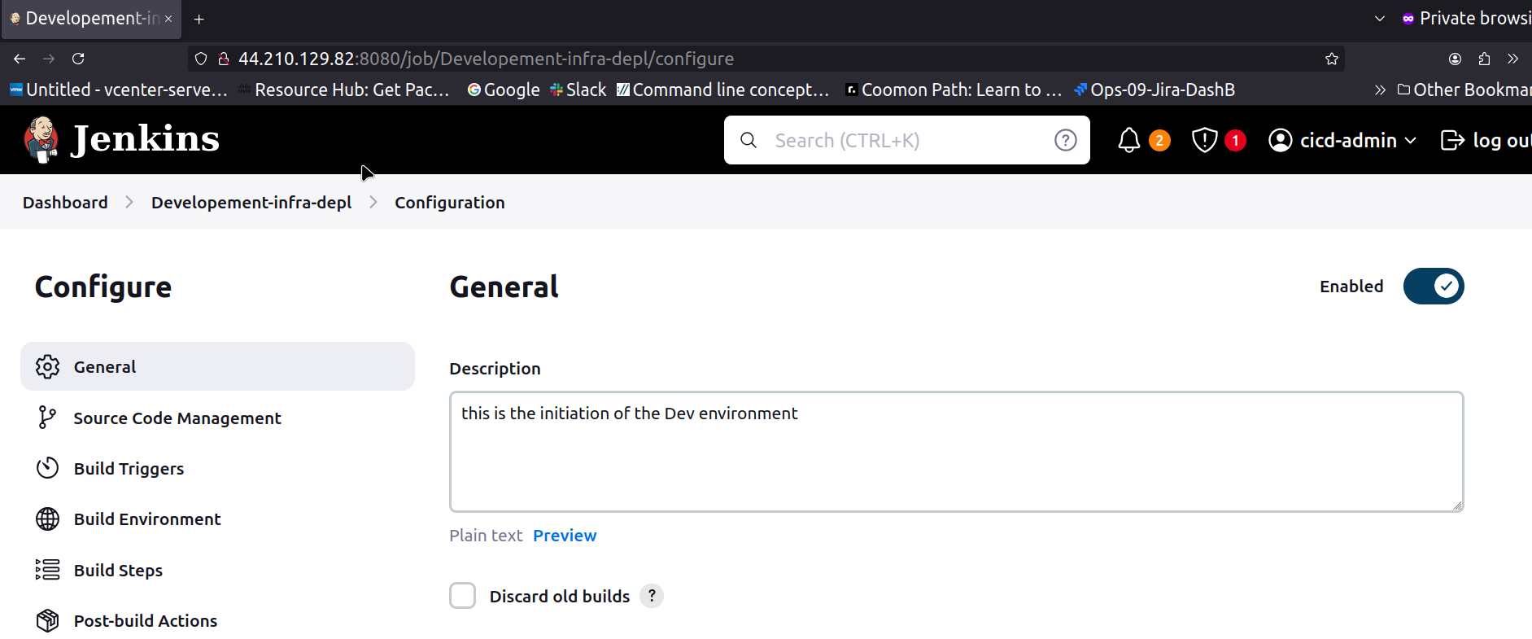

Install git on jenkins server before pasting the Public repo link in jenkins job configs.

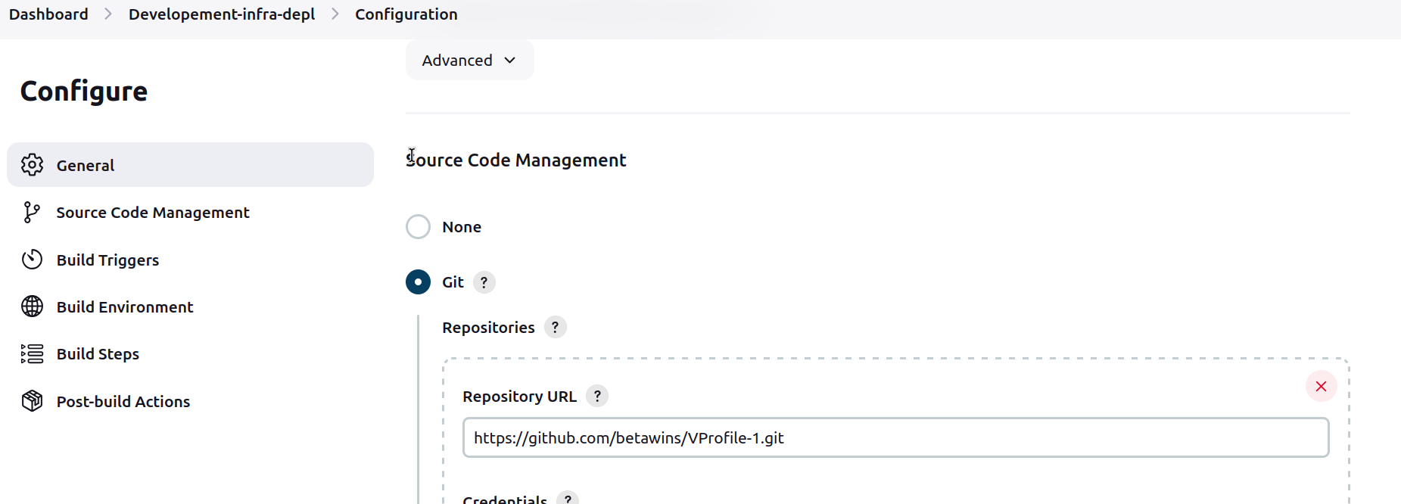  
Make sure the Branch is master/same on github .

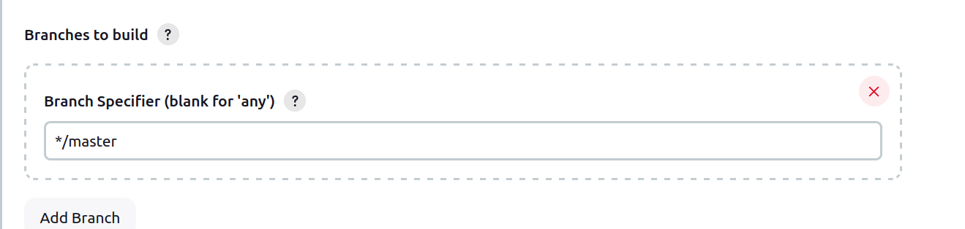

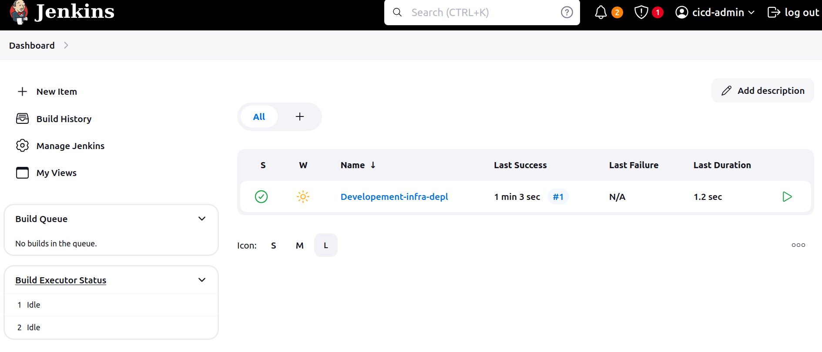

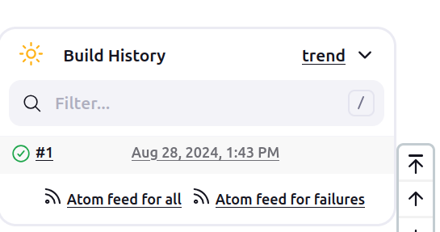

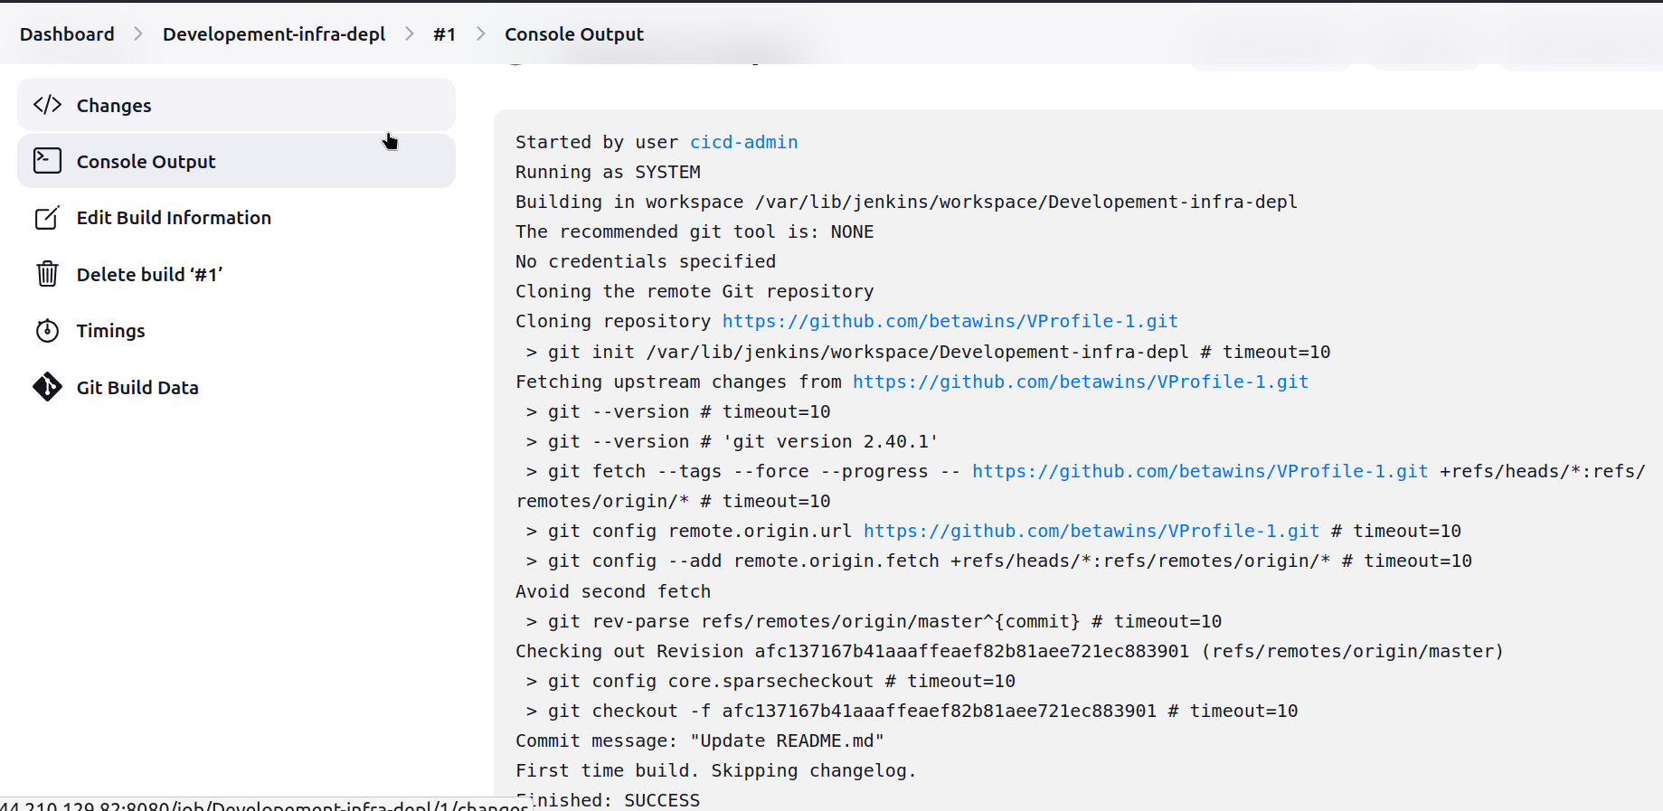  
Stage-1 is completed Git clone ==> To clone the source code

Stage-2: SonarQube Integration: To check for the Quality of code

To integrate with SonarQube a SonarQube server is needed

check quality of code, if it ain’t good, then code might leak the user data or someone can easily hack the code.

Metrics:

### Prerequisites

1. EC2 instance with Java installed

2. Use t2.large with atleast 20gb memory to run sonarqube.

1. MySQL Database Server or MyQL RDS instance.

Launch an instance with following configs hostname

'SonarQub-QC-server > AMI HVM2 > t2.large > VPC – default > Subnet us-east-1a > Enable Auto-Assign

IP > SG - default i.e all ports are opened > Storage -20GB >

- Install Java 1.8* - a pre-requisite or dependency

Database

- Add repo of MySQL - a post-requirement, **to save the results of the code analysis**

- Install MySQL -1 and import GPG key

- Install MySQL and Start service

- MySQL Initial Setup

- MySQL Setup for SonarQube

- Modify SonarQube properties file to connect to created database.Create a project on SQ for codeA

- Start SonarQube by starting it Service in specific location

- Install SonarScanner plug-in, Integrate SonarQube server via URL, Authentication tokeninS, credJ

- SonarScanner cli install setup

-

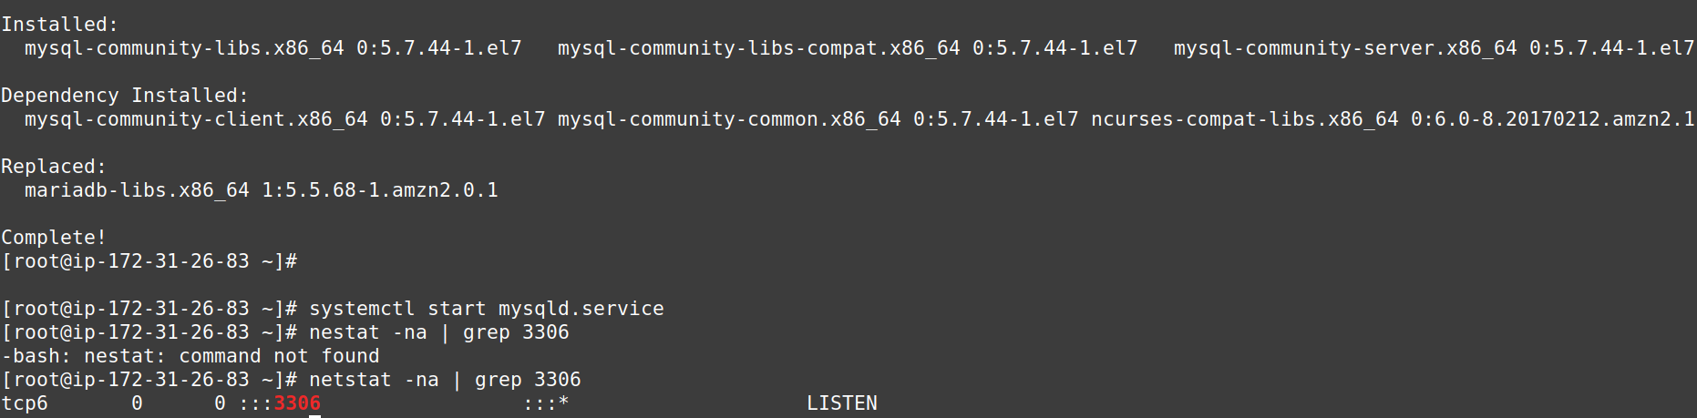  
SonarQube need a database. SonarQube needs to communicate with the database **to save the results of the analysis**.

MySQL Initial Setup:

check for temporary password provide for mysql db

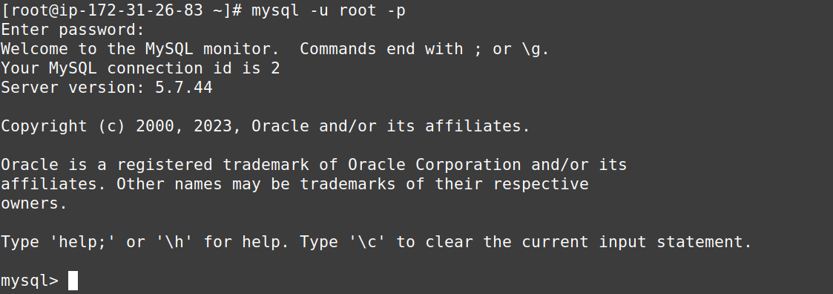  
Change the password for Admin user, update the privilages, exit and check.

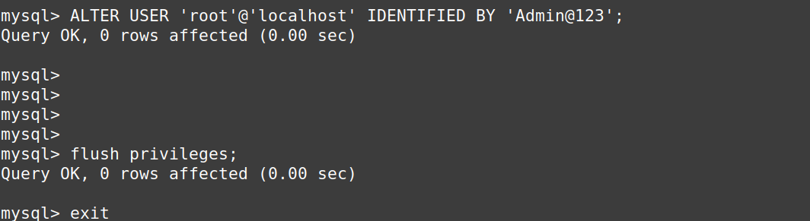

Use Opt directory to download anything.

Download SonarQube pkg from providede location

-Unzip the downloaded compressed package

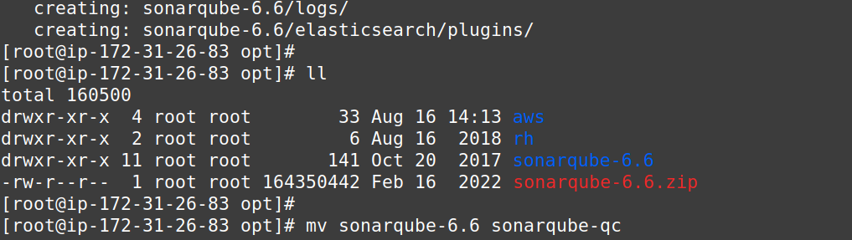  
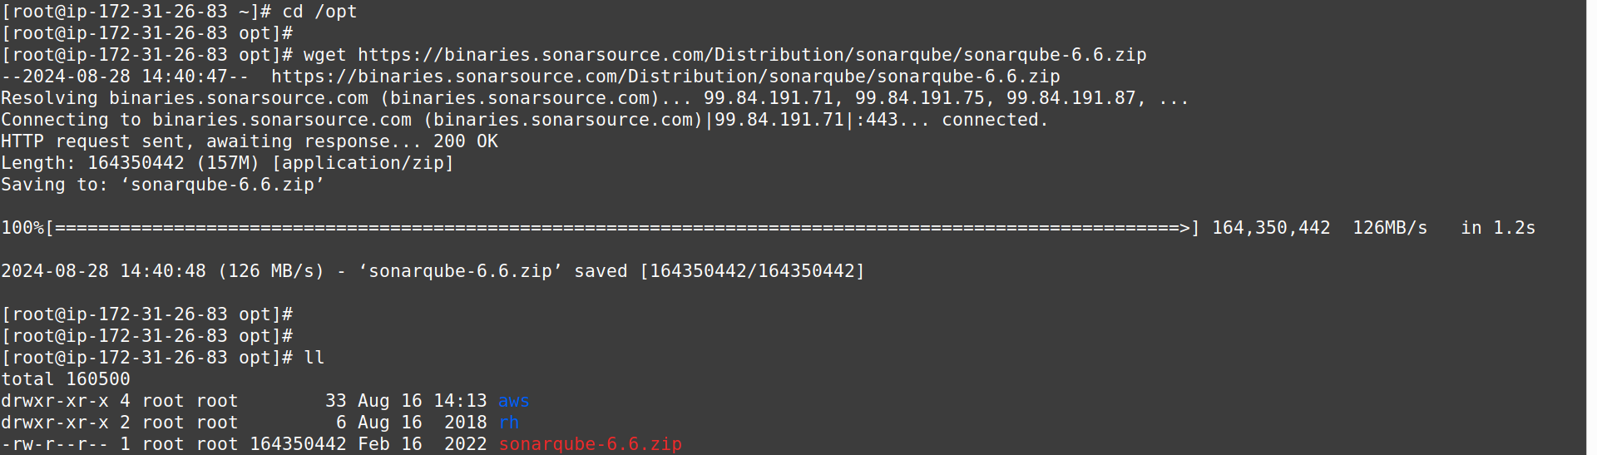  
MySQL setup for SonarQube:

Login

Create a new sonar database:

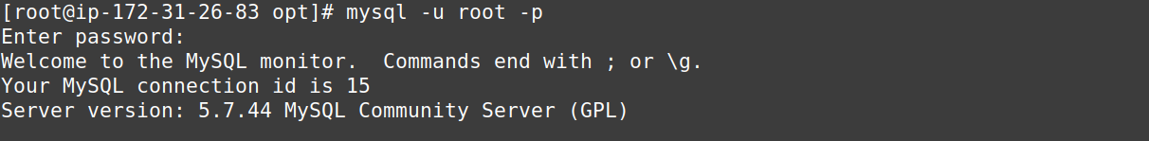  
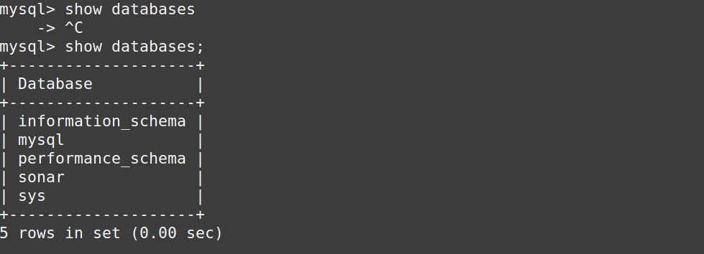

Create a local and remote user for created database which is for SonarQube:

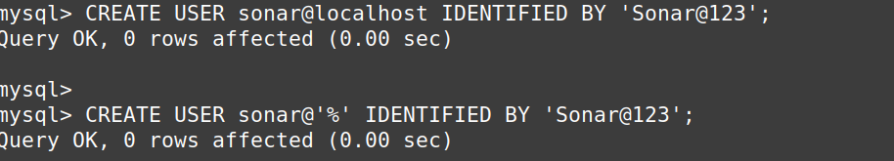  
Grant database access permissions to users. Allowing allow the permissions.

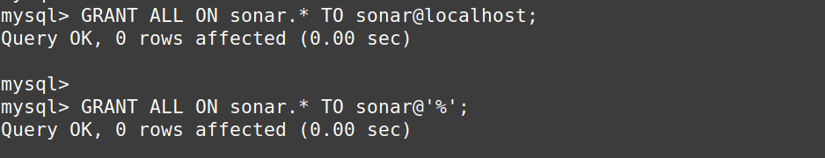  
Check users and databases:

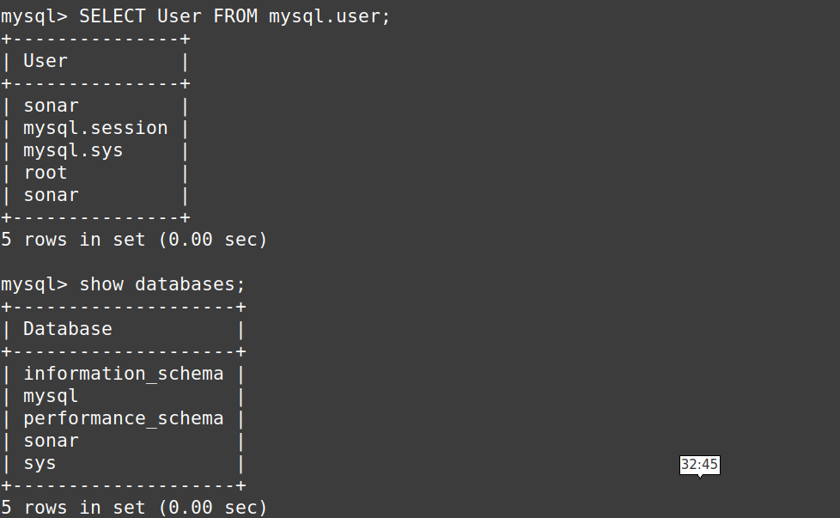

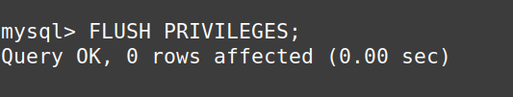

Setup related to Database is completed or done. Good to switch back to EC2

Jump back to your EC2 instance and enable SonarQube properties file to connect his Database.

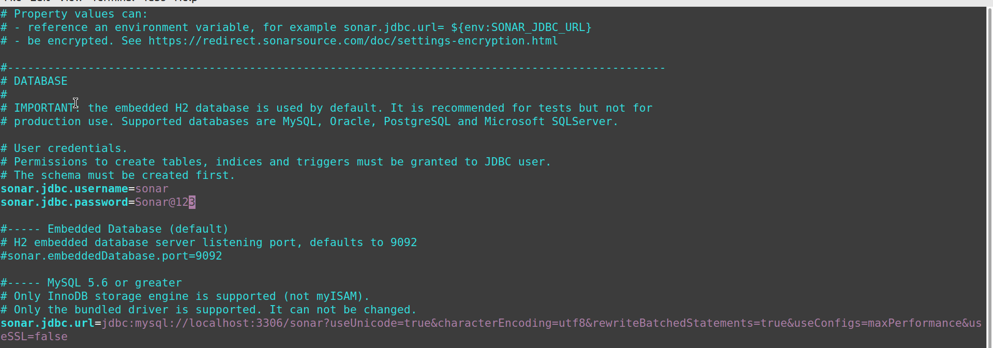And two more lines to modify

As we already have a user other than root and with sudo privilages, we aren’t creating a user and proceeding with to start the SonarQube by starting it’s service, which can’t be run being a root user.

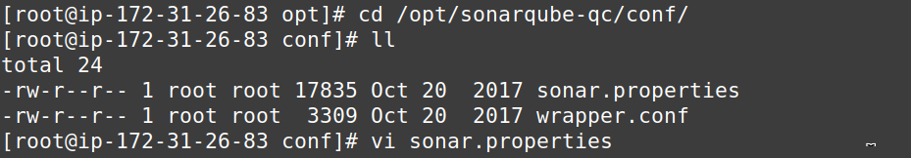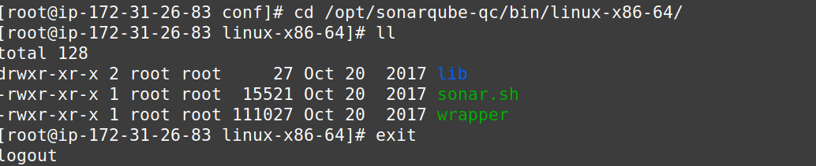

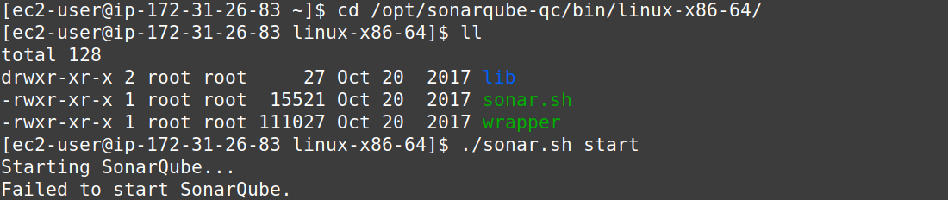  
Change the ownership of download and unzipped folder called sonar and then execute the script:

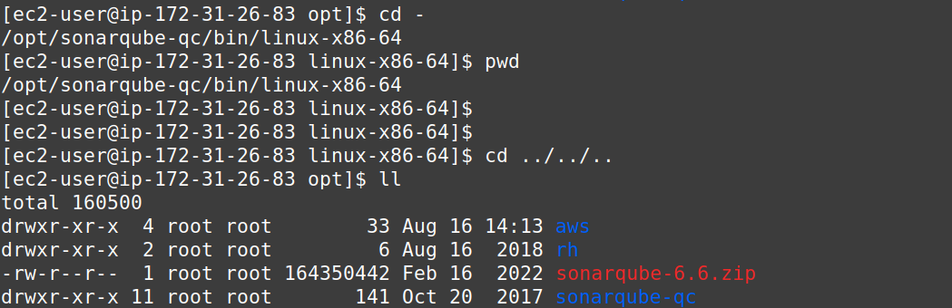

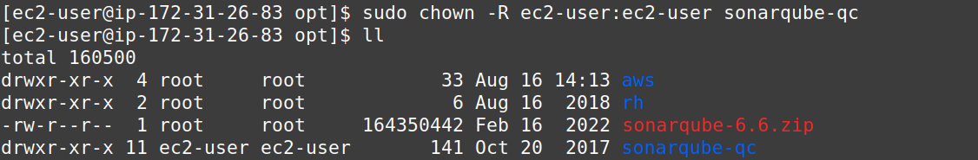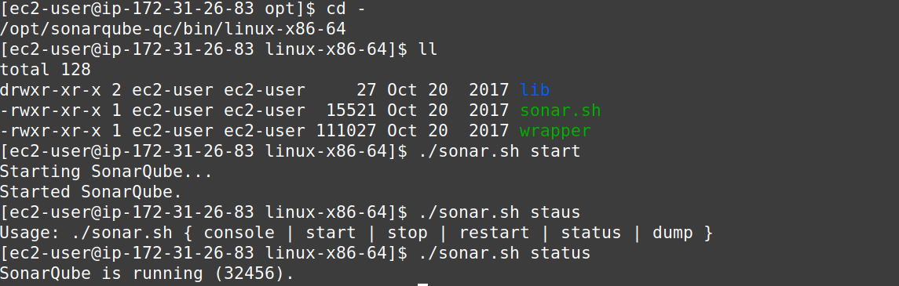Now SonarQube webpage can be accessed using PublicIP followed by port no. 9000

and remember, path prefix have been provided in the properties file of SonarQube, so that have to 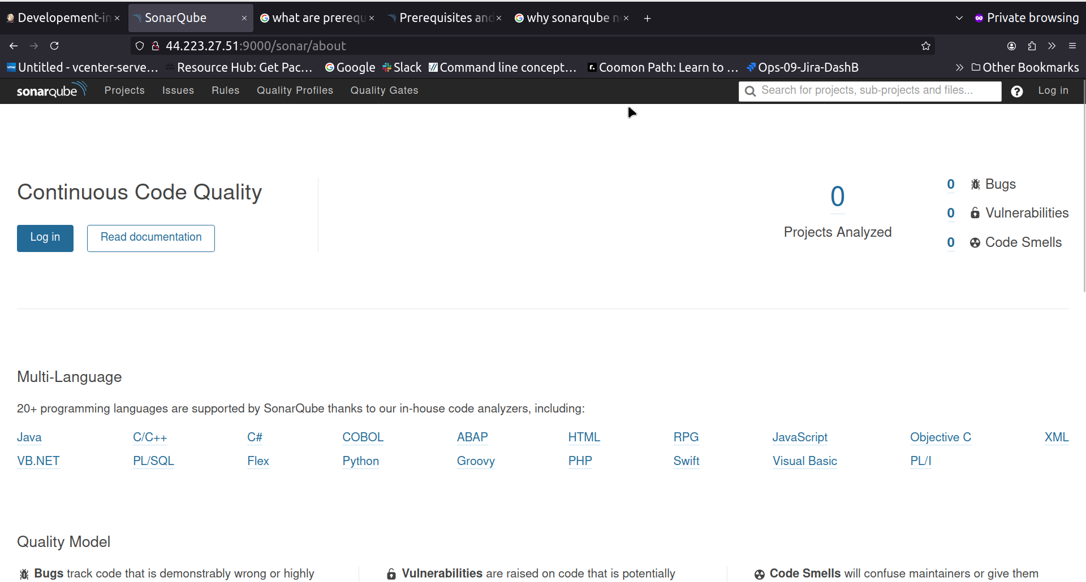be mentiond as well.

If in case of any error go to opt sonar-qc logs and check the logs

Now SonarQube webpage can be accessed using PublicIP followed by port no. 9000

and remember, path prefix have been provided in the properties file of SonarQube, so that have to be mentiond as well.

Goto Login > provide default Username and password mentioned in the document provided

admin

admin

Skip for now Generate Token prompt.

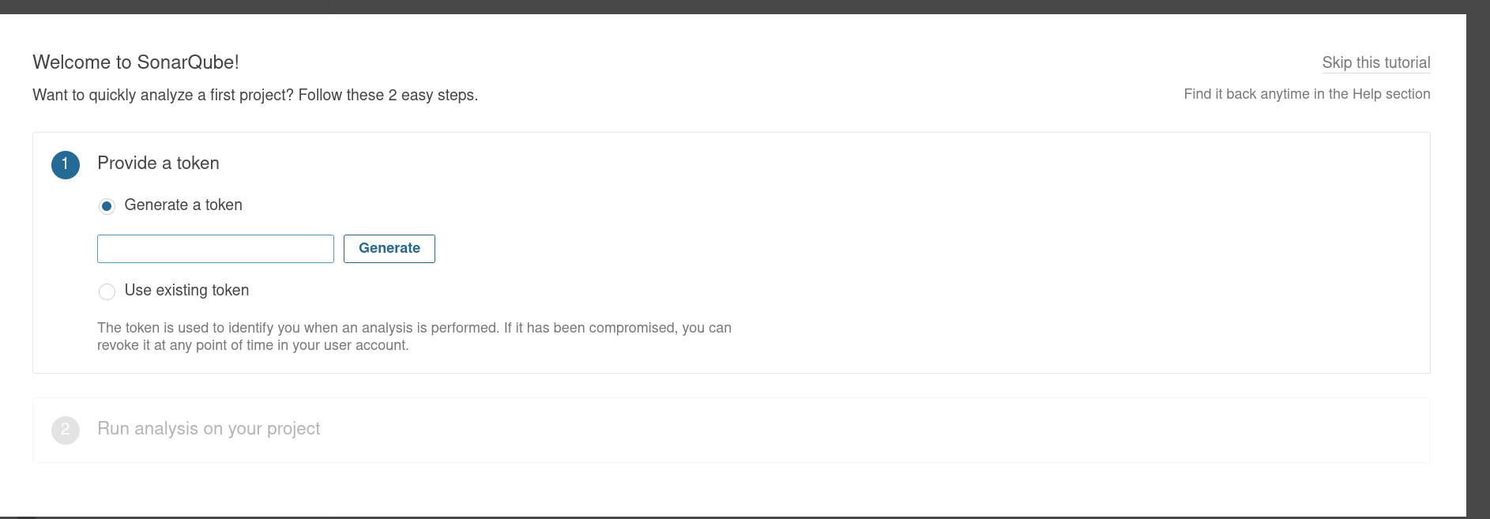  
Here is the SonarQube Dashboard:

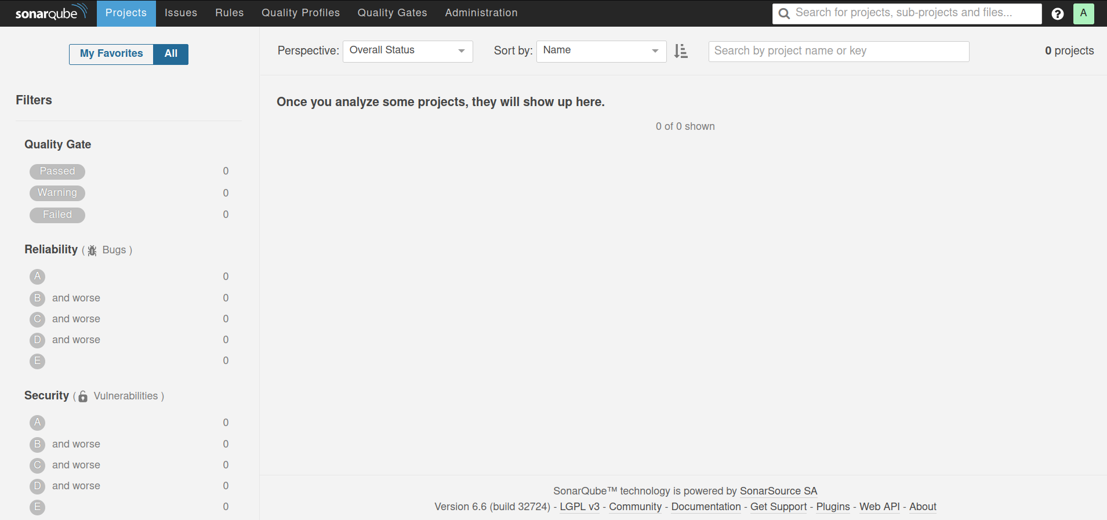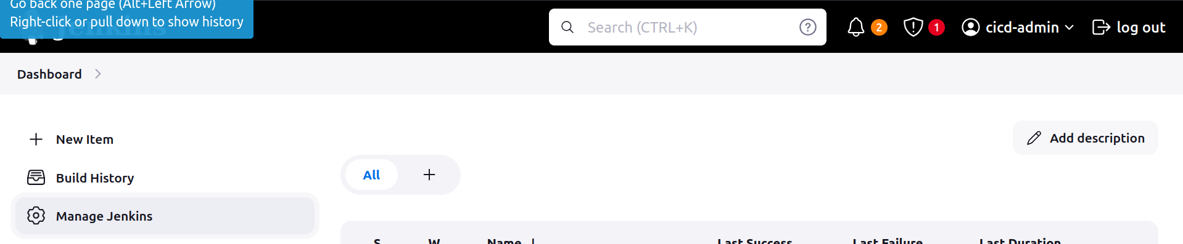  
SonarQube Integration with Jenkins:

Jenkins > Manage > Install Plug-in SonarQube Scanner

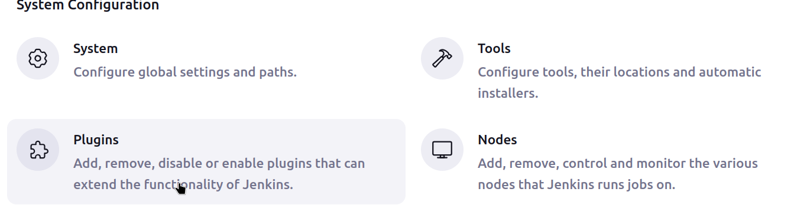  
Available Plug-ins

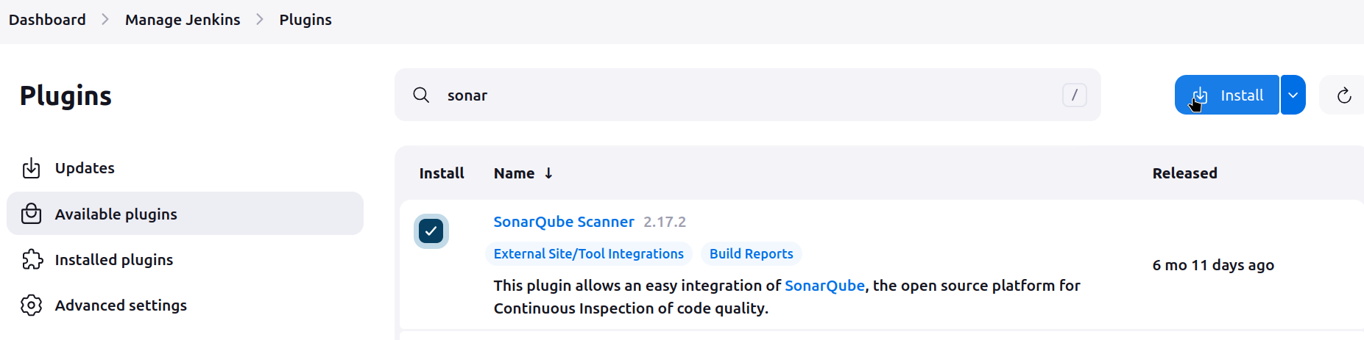  
Once Installed will have new and Extra option for SonarQube

Manage jenkins > System > SonarQube servers

Under DashB > Job > Configure > Build Envir / Build Steps >

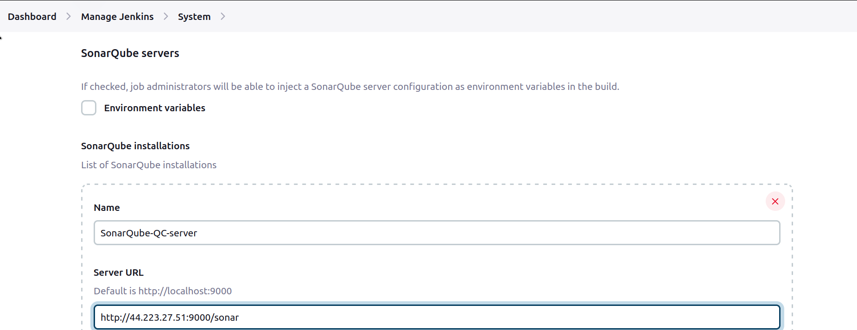

Authenticaion

Configure credentials:

Create Token

Log in to SonarQube > Administrator > my Account > Security Tab > Generate new token > name it as ‘sonarqube-api’ or any

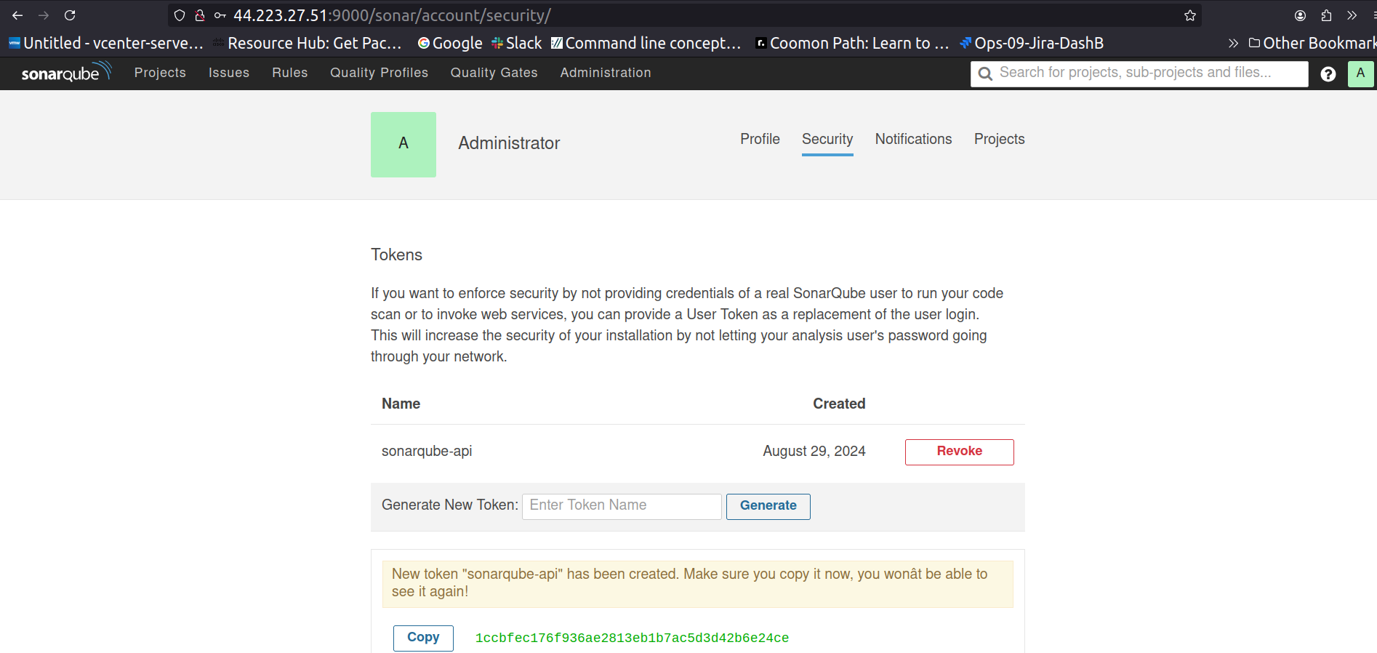

Create a Credential on Jenkins

Jenkins > DashB > Manage J > Credentials > System > Global Creds (Unrestricted) > Add Creds

Select ‘Secret Text’ option from Dropdown >

Scope shall be global not just Jenkins >

Copy paste the Generated Token as a Secret > Create.

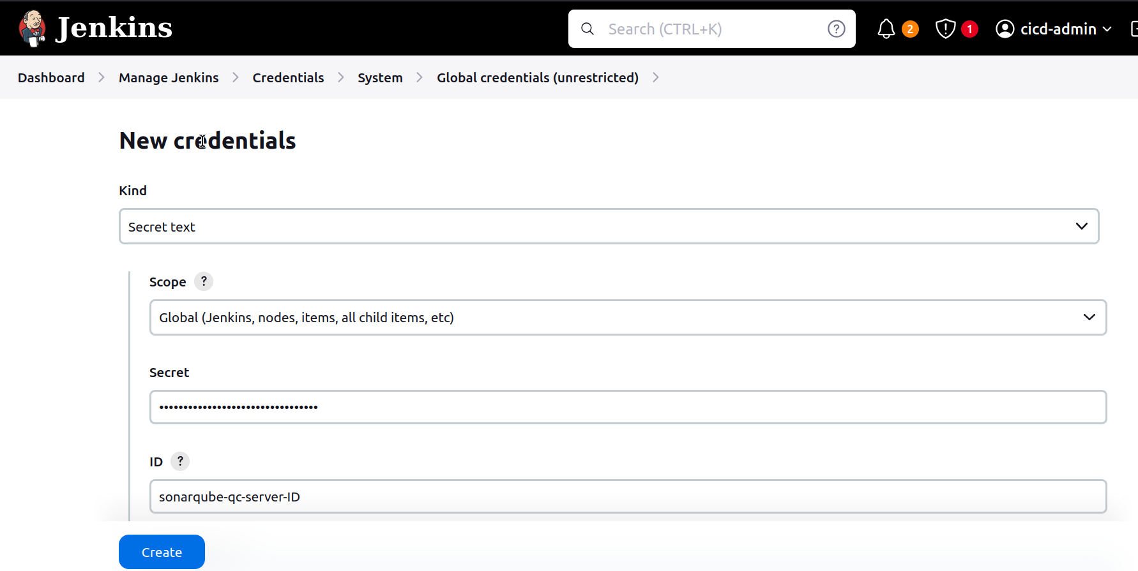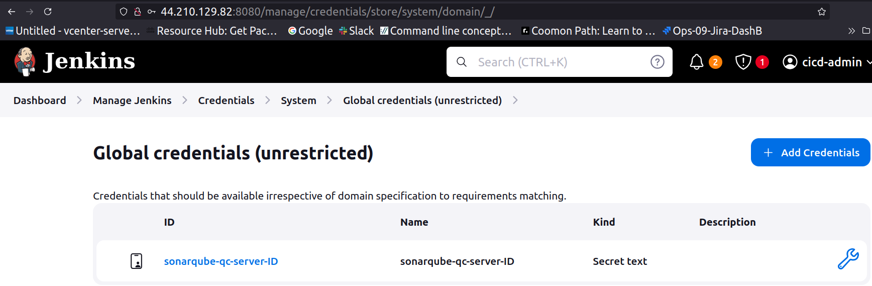

Jump back to SonarQ Integration steps

Under DashB > Job > Configure > Build Envir / Build Steps

If SonarQ authentication token isn’t reflecting refresh the webpage

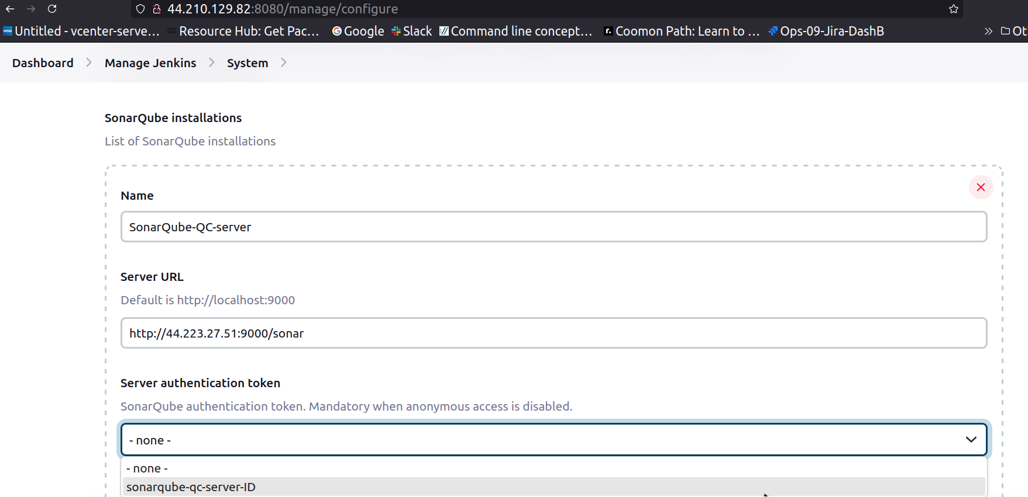  
Save.

So, We have connection between a Jenkins and SonarQub server, now there should be an Agent which will monitoring and reporting of whatever being generated on Jenkins server should be sent to SonarQube, a mechanism

For this purpose, there is an Agent called “SonarScanner” in Jenkins.

SonarScanner is responsible to push all the report to SonarQ Server from jenkins.

i.e, SonarQube scanning

Jenkins   
 Installed plug-in SonarQube

SonarQube Server

Incomplete

SonarScanner Plug-in was to connect / Integrate

SonarScanner CLI

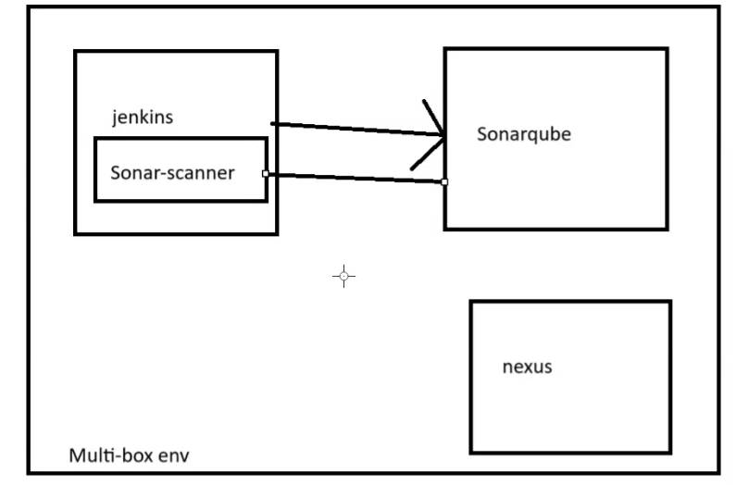

The sonar-scanner orchestrates and runs the analysis, generating all the data (issues) that is sent to SonarQube for processing (tracking issues, computing measures, and integrating with other services such as running Webhooks or decorating pull requests).

With the sonar-scanner you would just have a list of issues. With SonarQube, you can track the state of your codebase overtime, manage the results, and make sure you focus on, for example, new code.

The sonar-scanner is occasionally updated to interact better with SonarQube, but ultimately it’s downloading all the logic from SonarQube. So you should keep the sonar-scanner updated, but for new rules and new language revisions, what really matters is the SonarQube version.

On Jenkins-Server switch pwd to opt

Download sonarscanner pkg file unzip rename

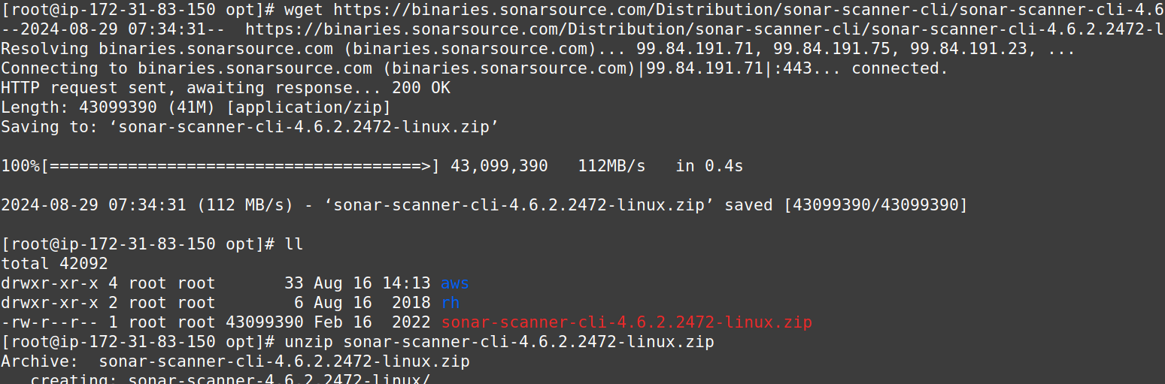

Rename unzip directory to simpler name maybe “sonar-scanner”

Set SonarQube server details in sonar-scanner property file On Jenkins

Append host URL with PublicIP and path prefix

on Jenkins server

   
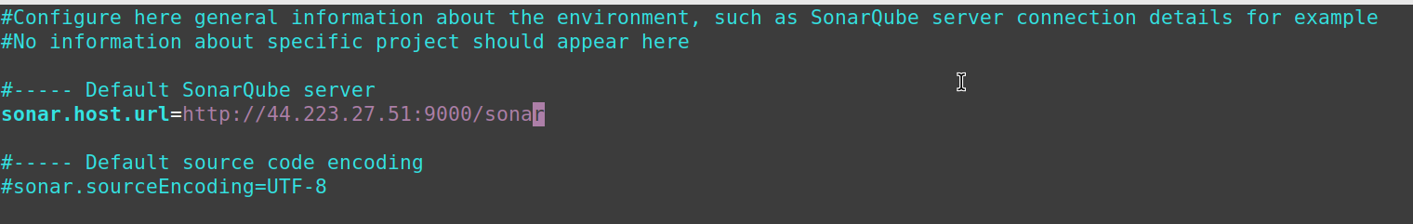

Configure SonarScanner Homepath

Manage Jenkins > Tools > SonarScanner

Since we have installed manually we will be passing the path manually

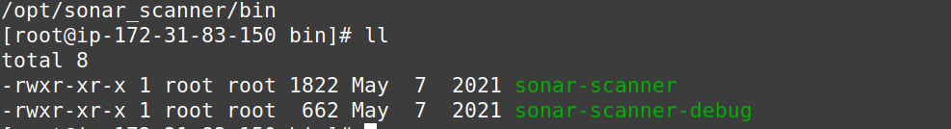

In this location we have SonarScanner

If we go with the Install Automatically option it will download the latest version,

and if Application supports SonarScanner 4.0 instead of latest 5.0

So, the Pipeline will get fail, because of the Change in dependcies

Do Not Use “Install Automatically” option

Always try to install manually and provide the path

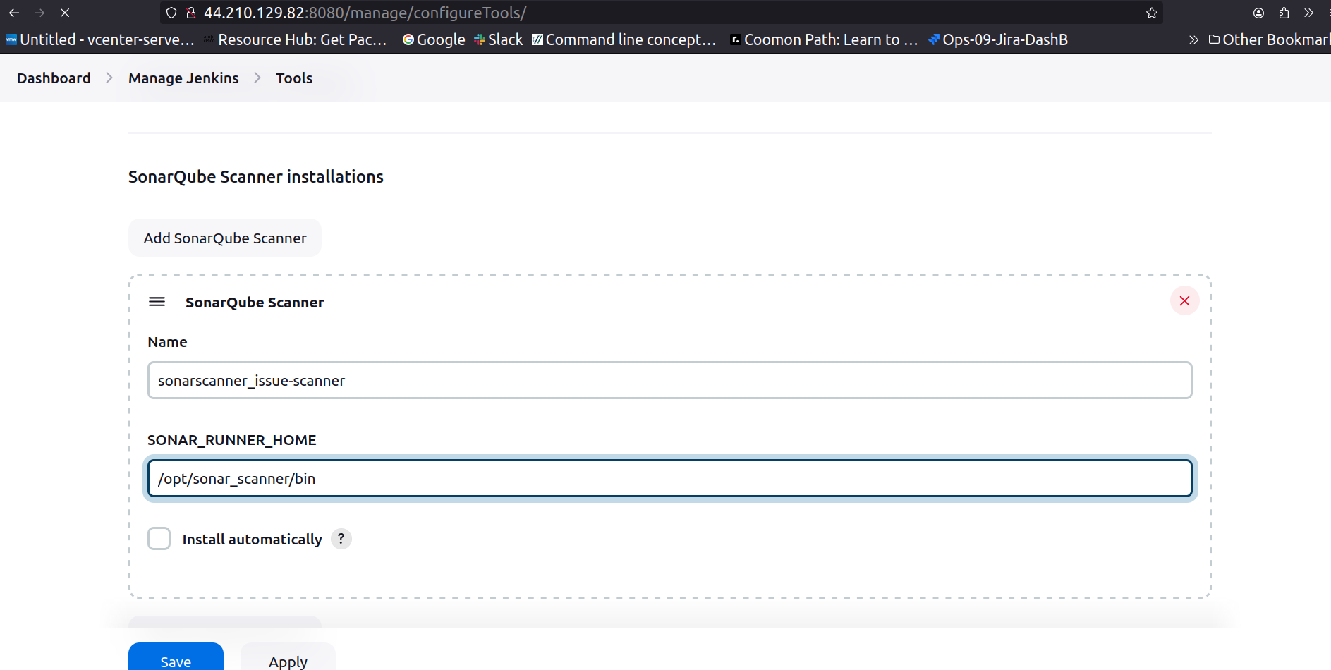WITHOUT /BIN IT WORKED!  
Now, we are good with the Configuration of SonarQube and SonarScanner.

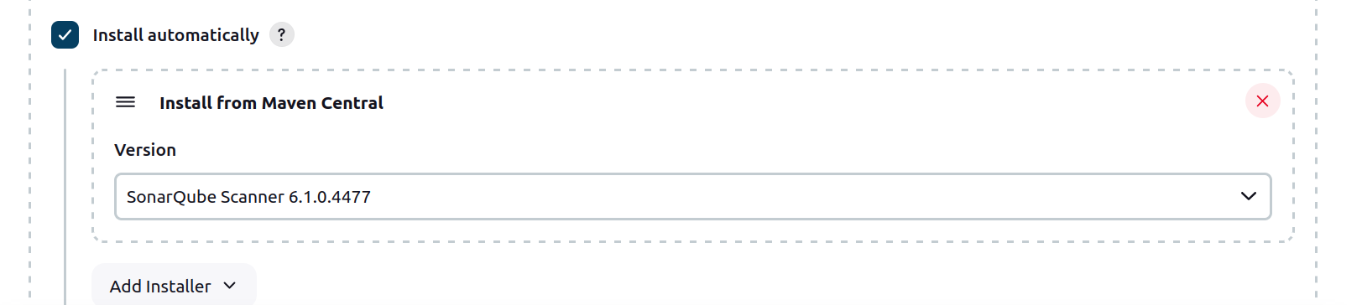Figure 1: Figure: Option shown Image is not the part of process

Now, we need to provide the details for the Jenkins Job saying goto this Scanner and check for the reports

DashB > job_name > Configuration > Add Build Steps > Execute SonarQube Scanner

goto this Scanner > Pass inforamtion -JDK -Path to Project properties -Analysis properties

which will be provided by the Developers

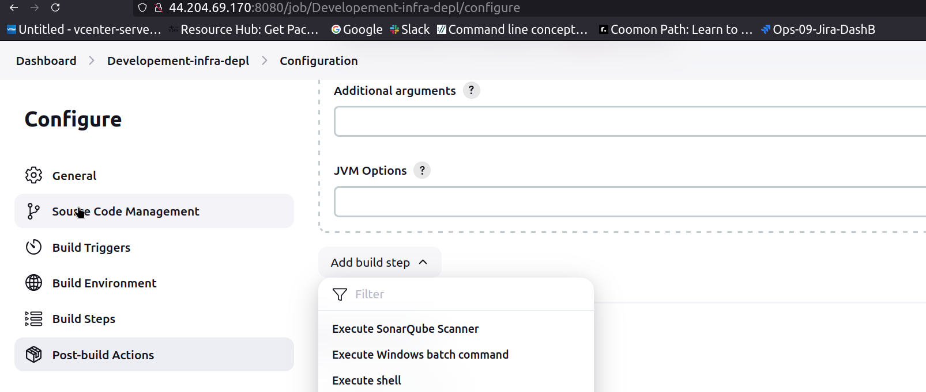  
Note: Path here should be menitoned of sonarqube directory on jenkins server,Not Sonarqube server’s directory.

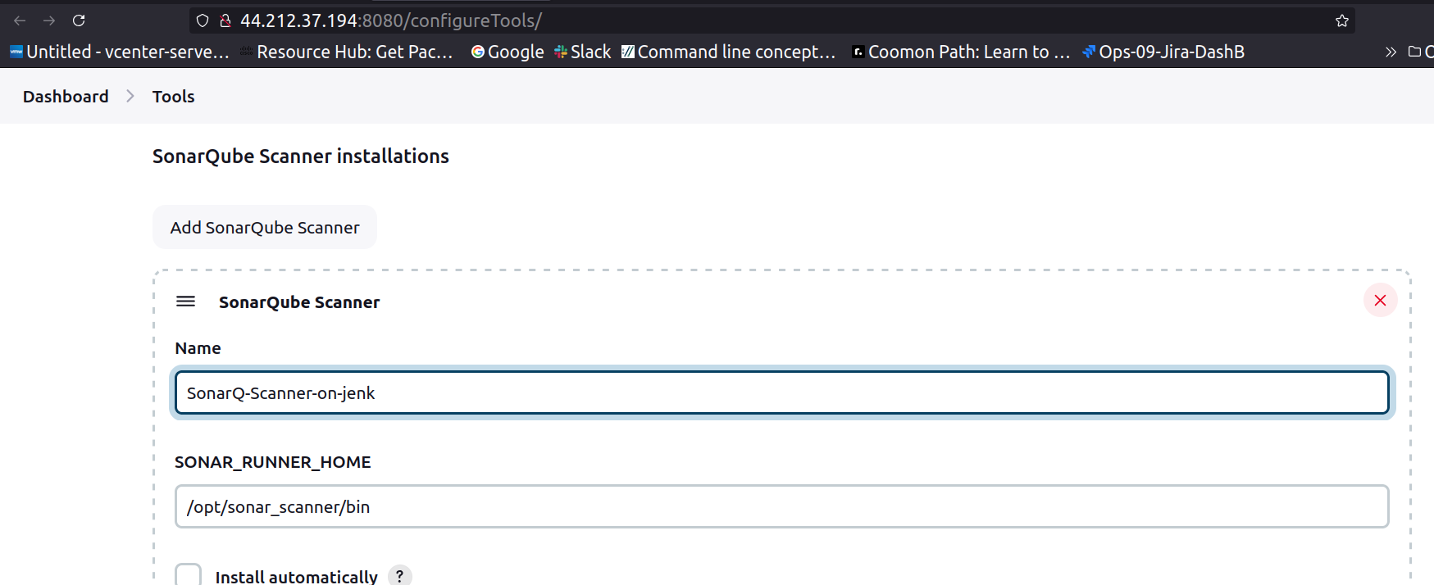  
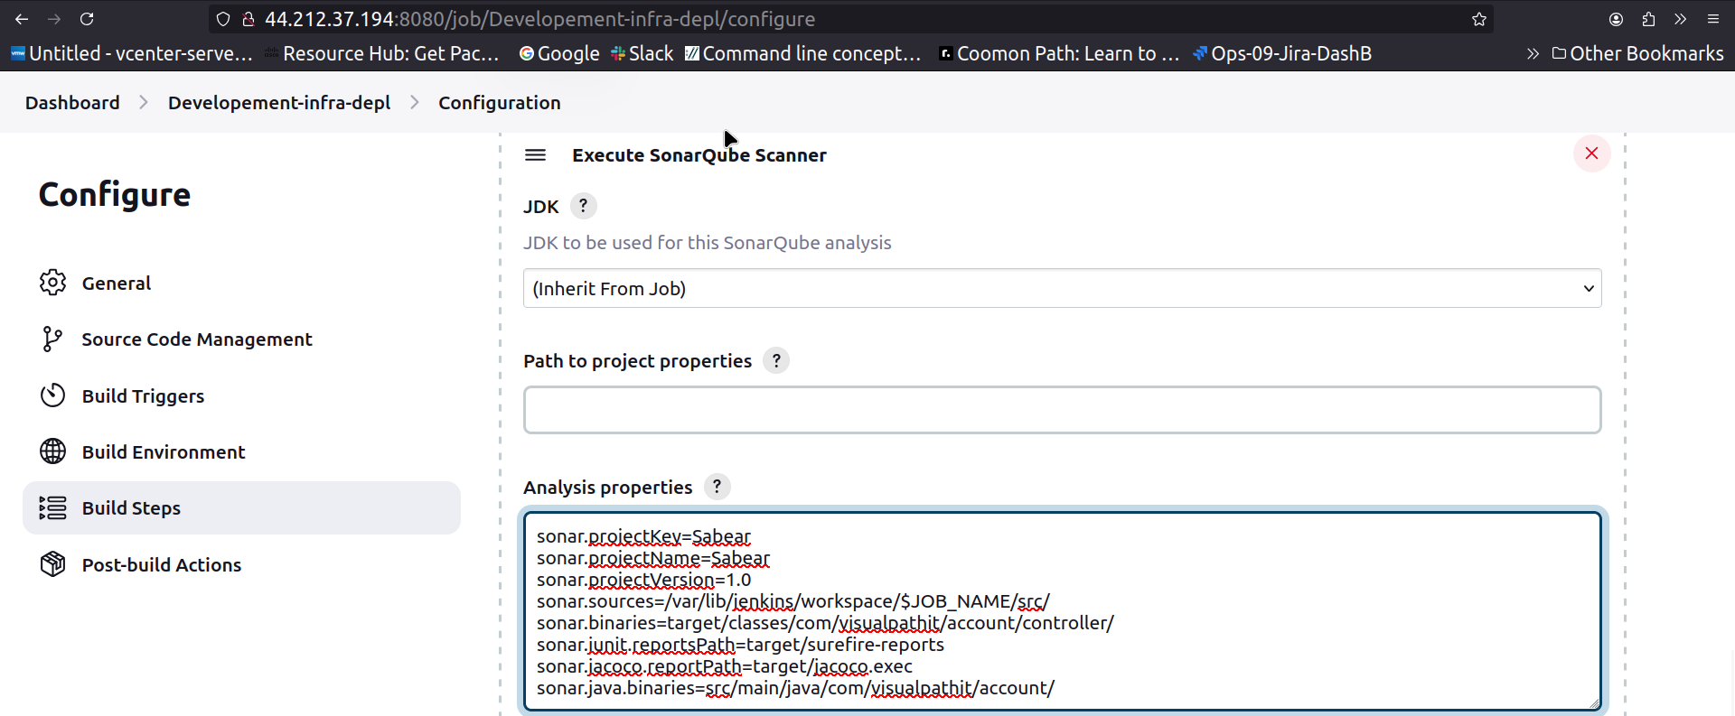

once saved, if check under job name will be changed to SonarQube

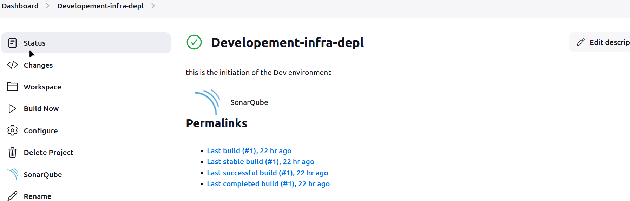

start the build and check the Console output and the code will be executed and finally at last there will be report generated and will be sent to the provided location/IP.

Job run/Build was successfull after few errors and lot of troubleshoots

Setup SonarScanner and Integrate SonarScanner with SonarQube

Slack integration

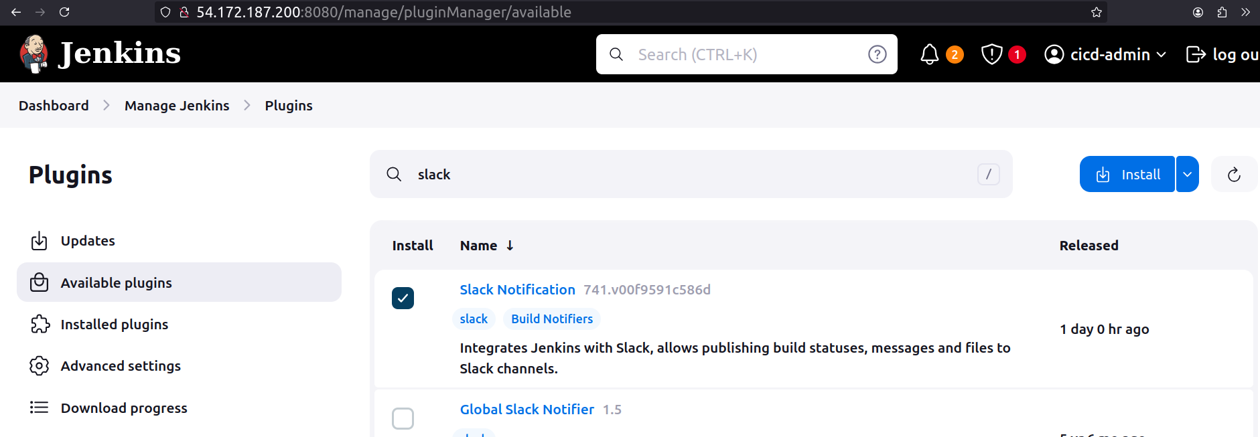  
restart needed

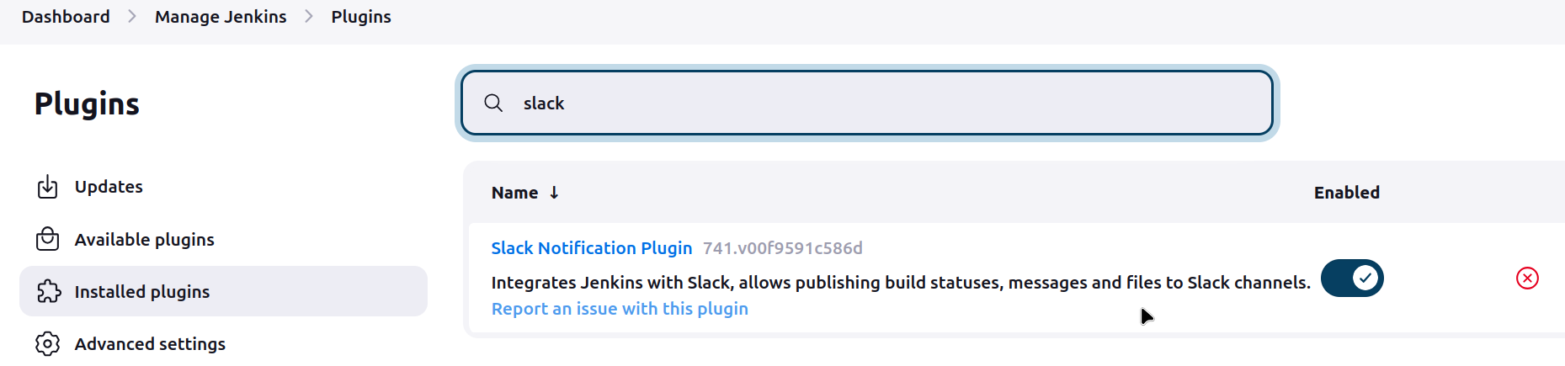

Manage J > System > slack >

Slack > Dropdwon beside Workspace name > tools > Manage Apps > Search/check in list for Jenkins CI > click on it > app details > Add to Slack >

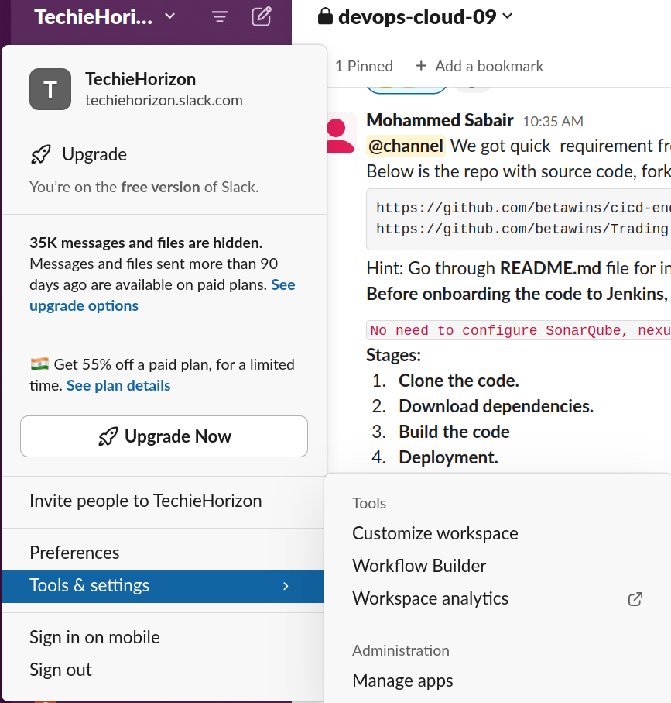

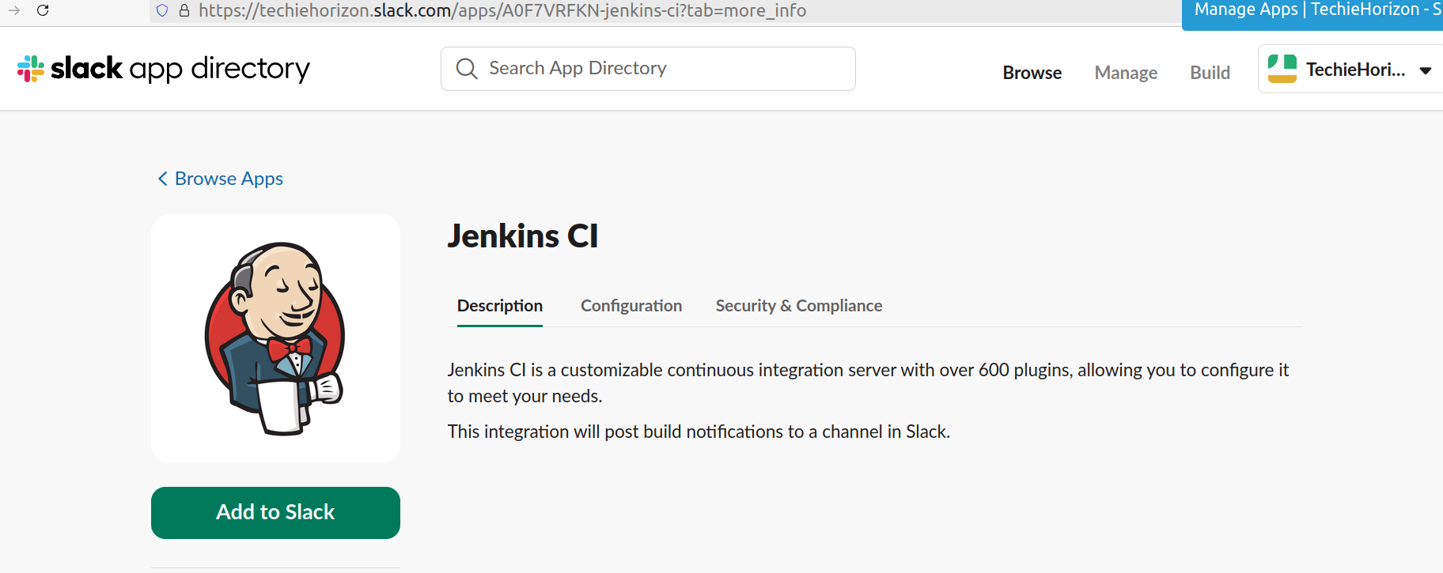  
Click on Add to Slack > insert slack workspace name > click on Add credential > select secret type of global creds > Paste the secret from the page loaded after click on Add to Slack.

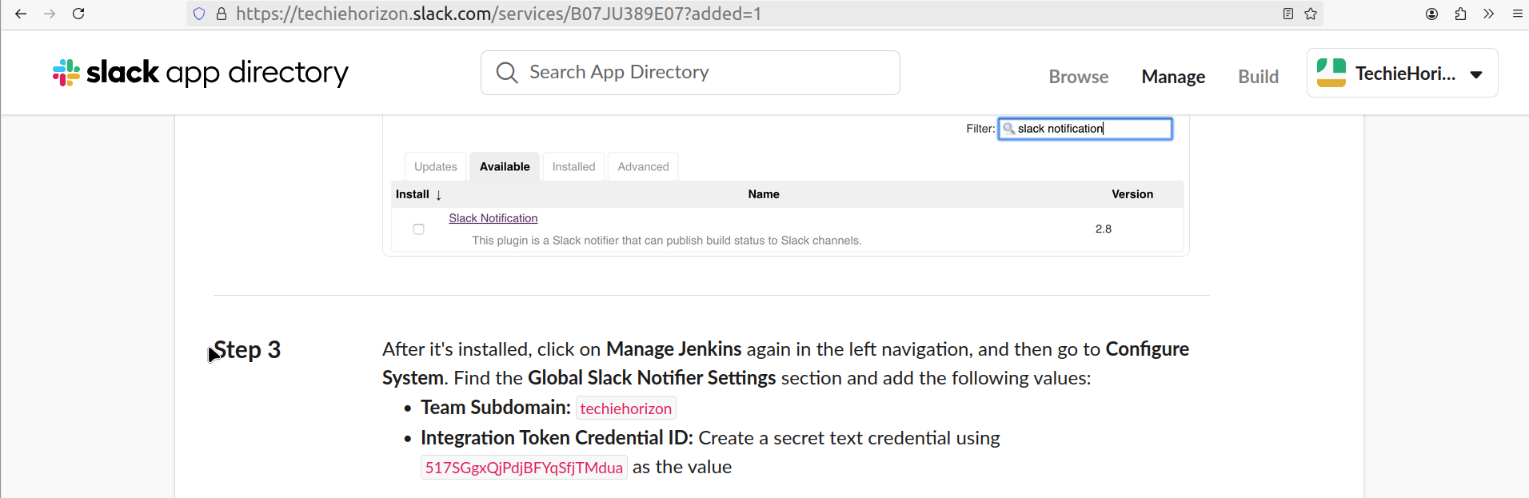

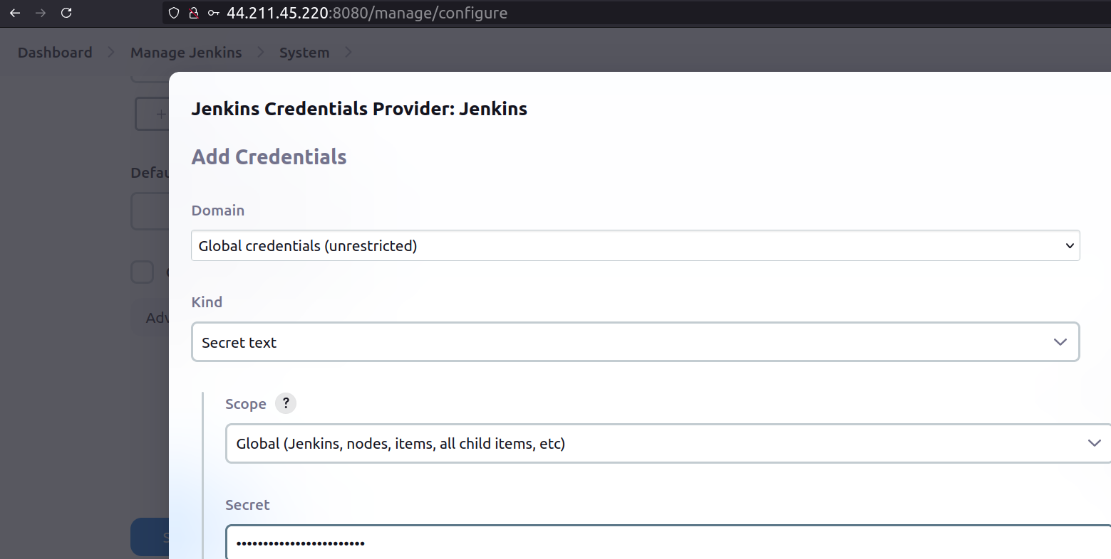  
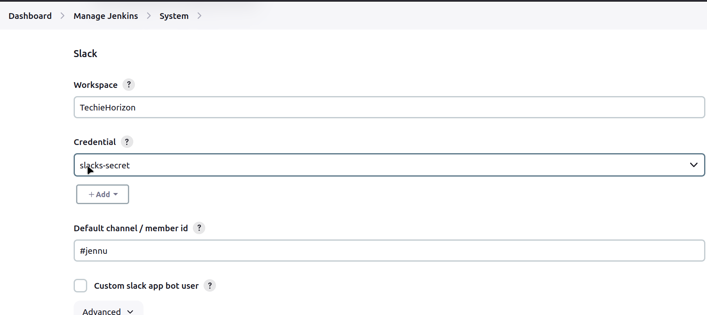

Click on test connection > Save.

More configuration can be set from the Slack webpage that loaded after clicking on ‘Add to Slack’.



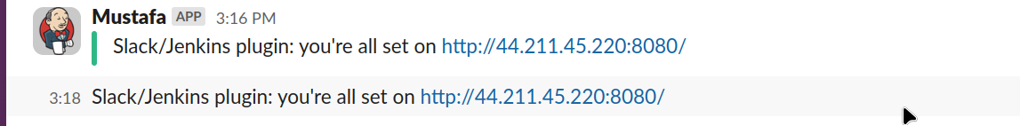

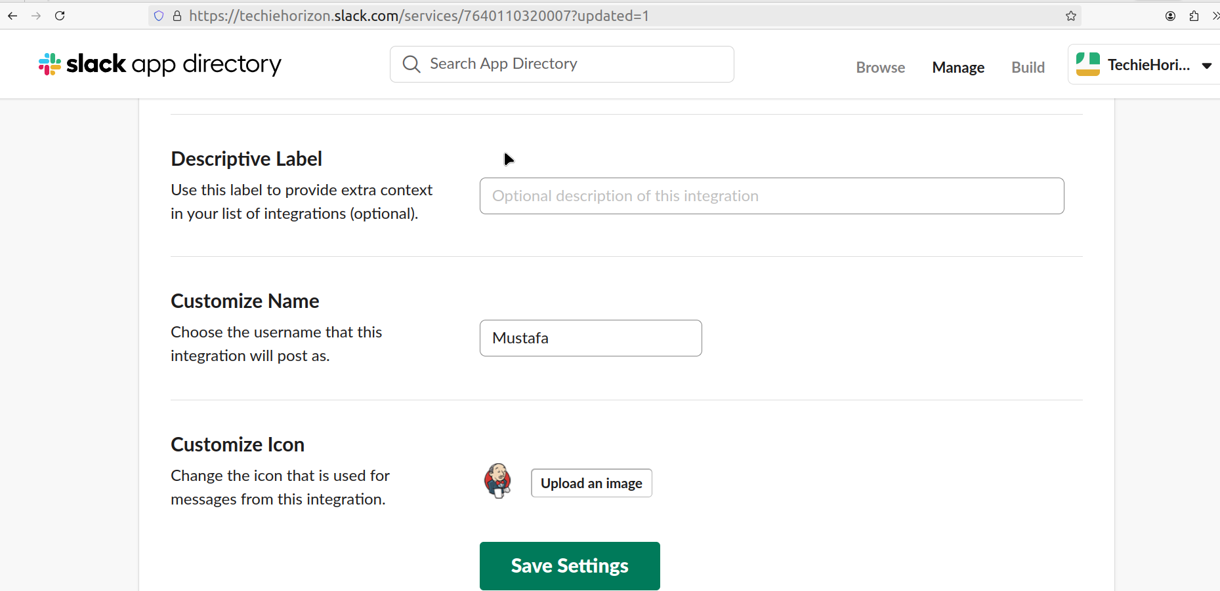

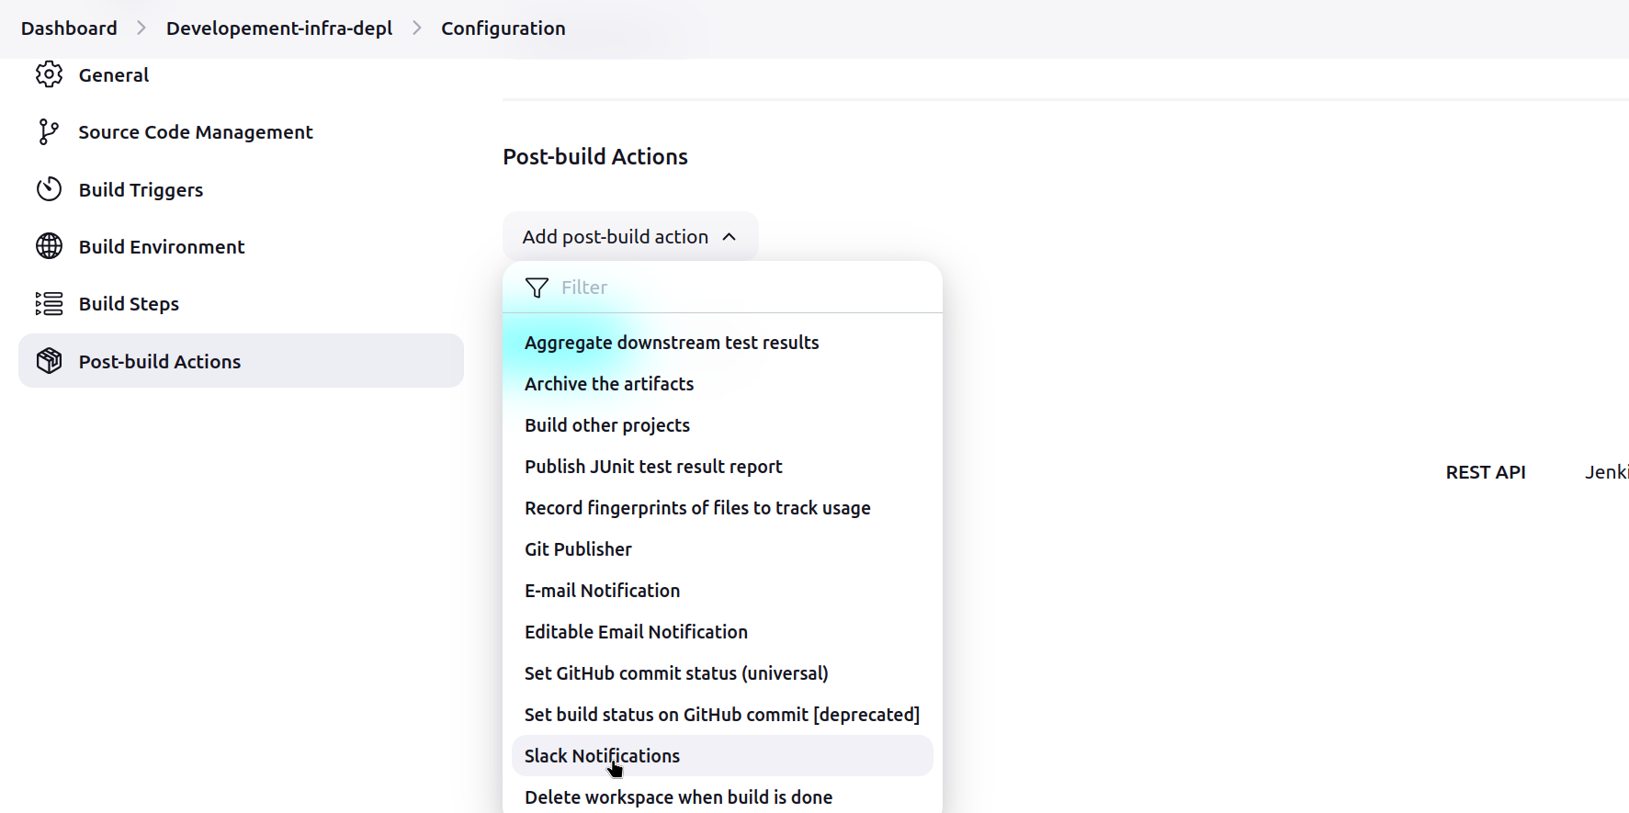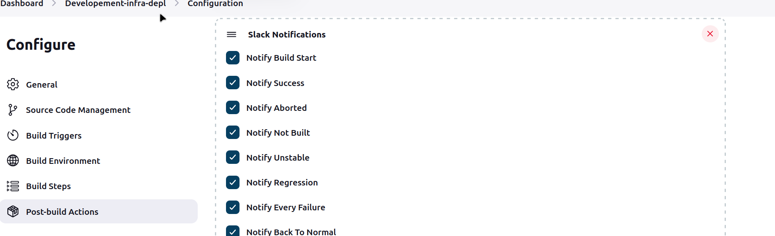

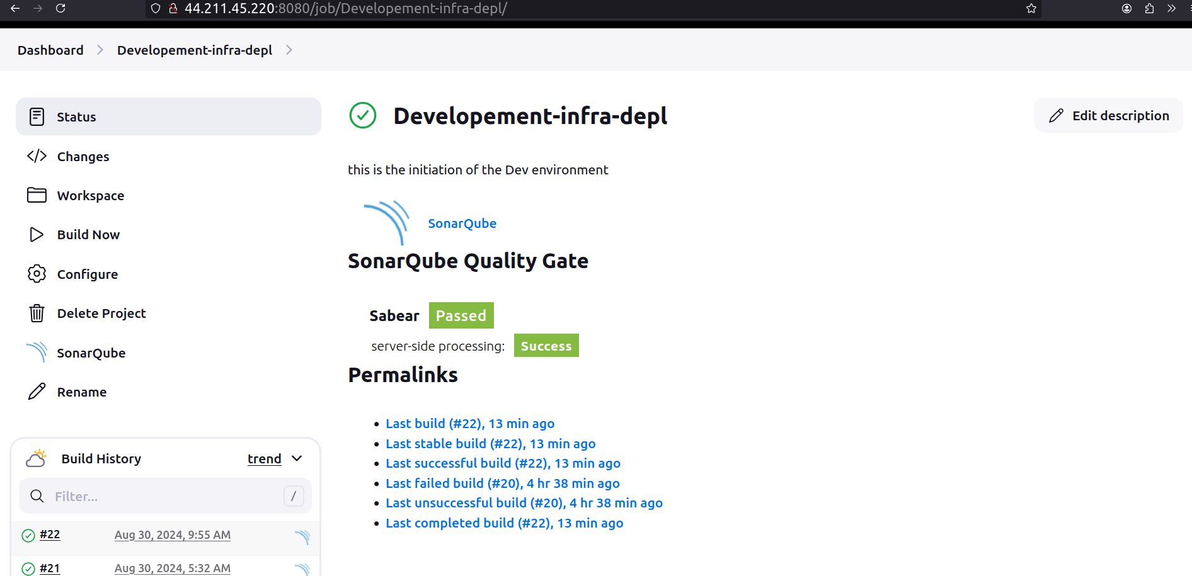  
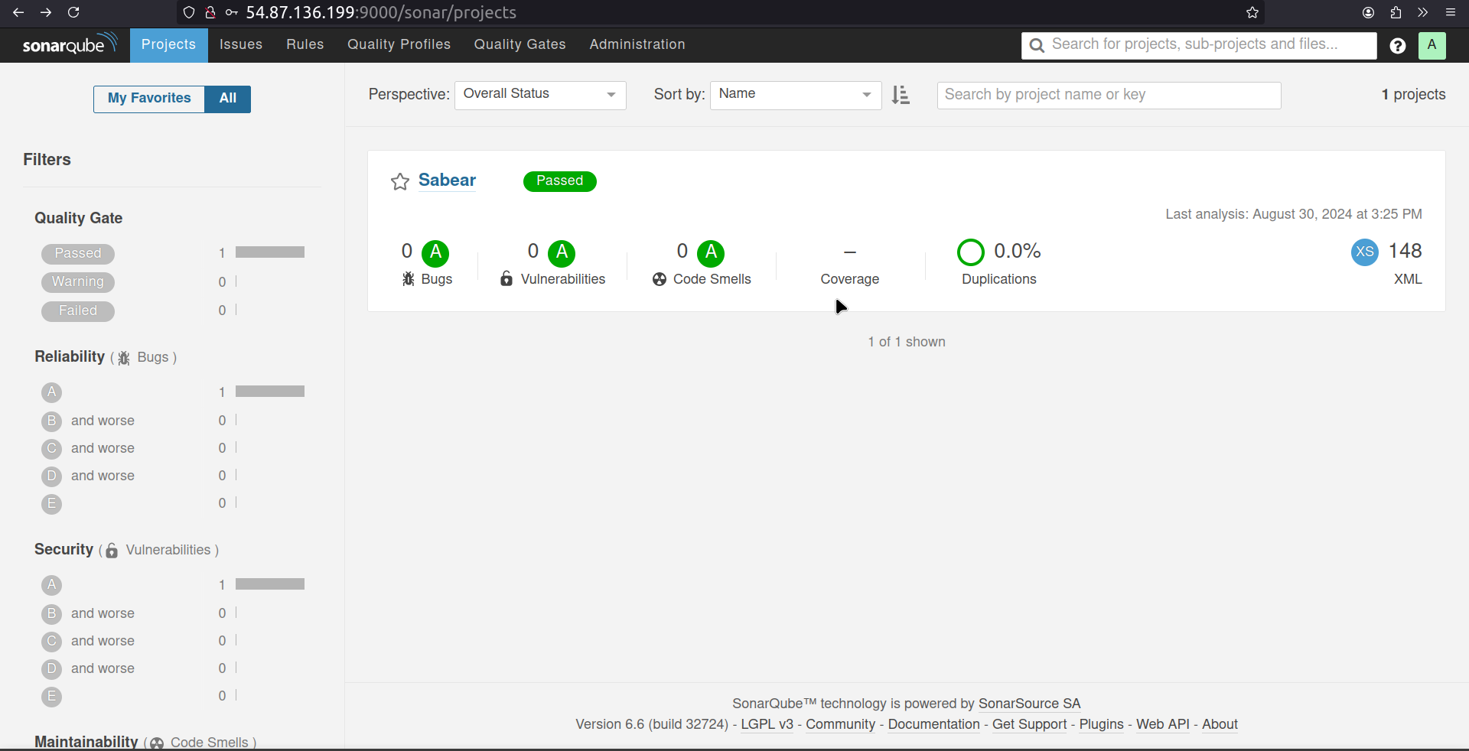

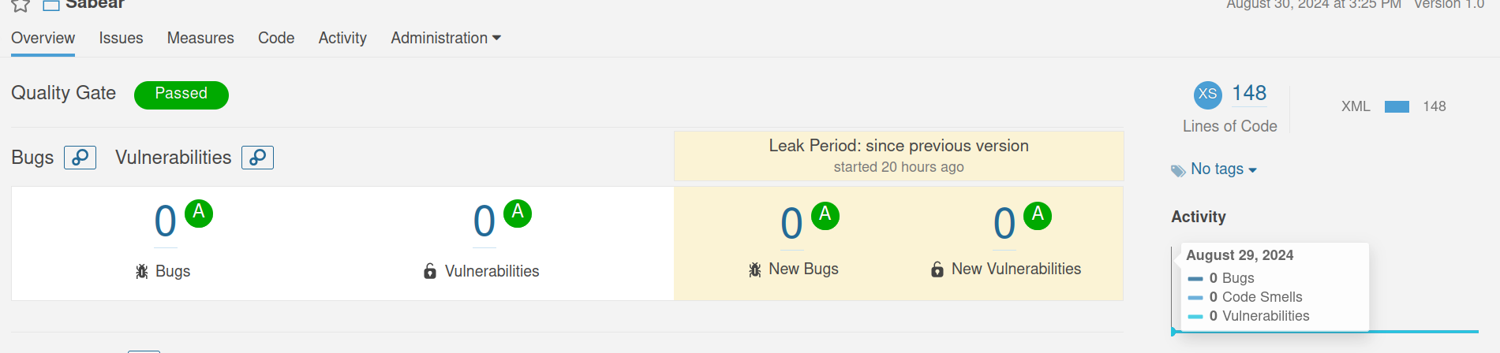

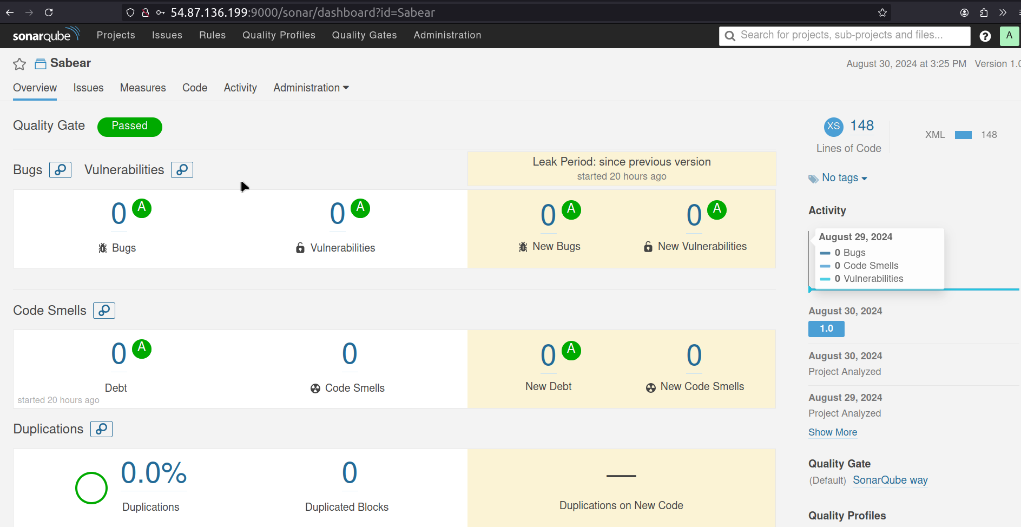

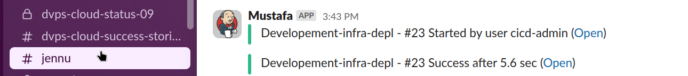

Task: Through Docker

Installation and Setup of SonarQube using Docker:

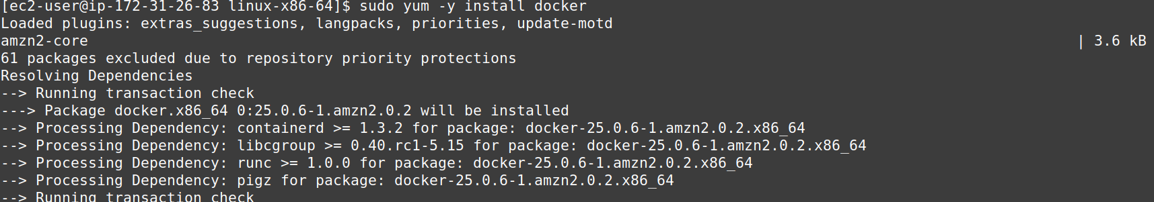  
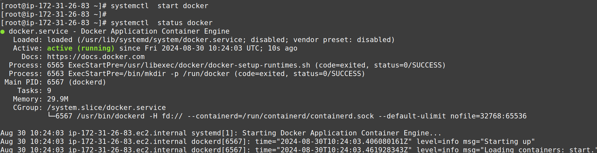  
Pull docker image

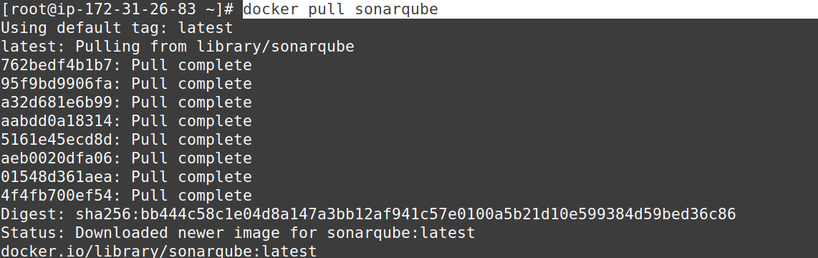  
Since already a SonarQube server is running on its default port number 9000,

the port no. For other SonarQ server have to changed to other port to function.

#docker run -itd -p 9002:9000 sonarqube



One Container can be seen running on port no. 9002

  
Copy PublicIP

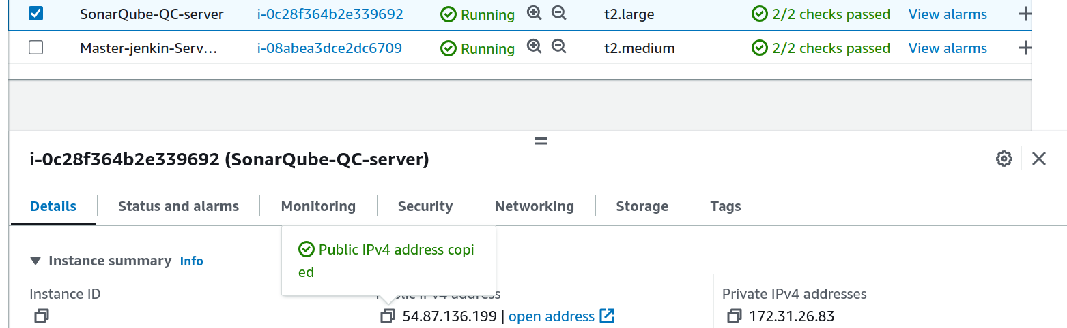  
Everything will be setup by default, No need to config mysql

Within 2 mins SonarQ server can be setup.

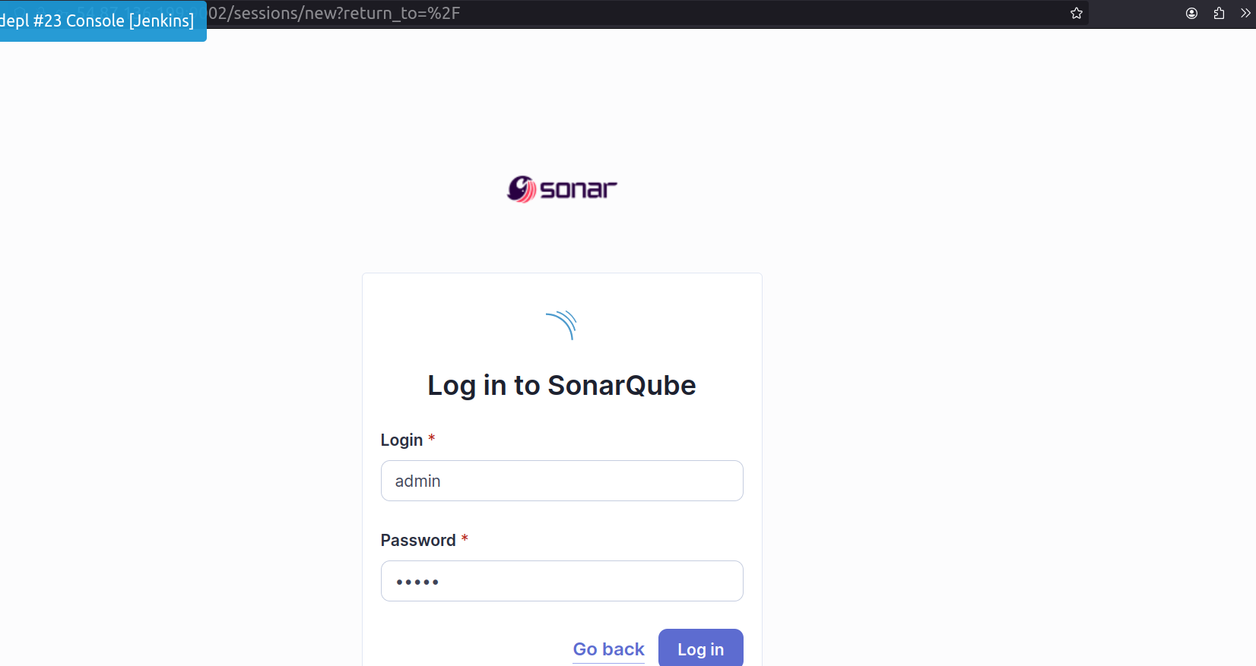Check in browser using publicIP:portnumber9002

Now, SonarScanner need to be configured; by changing the port number (& path), so that

SonarScanner should push the jobs on port 9002 instead of 9000

No IP modifiction is needed as in this case same server is being used for SonarQ server setup

SonarScanner Setup on Jenkins Server for ‘Jenkins-SonarQube Intergration’: 1.

(an agent)|

For generating Reports and sending reports to SonarQube for static code analysis:

on Master-Jenkins server

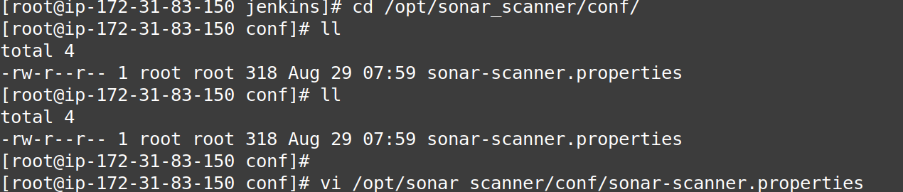  
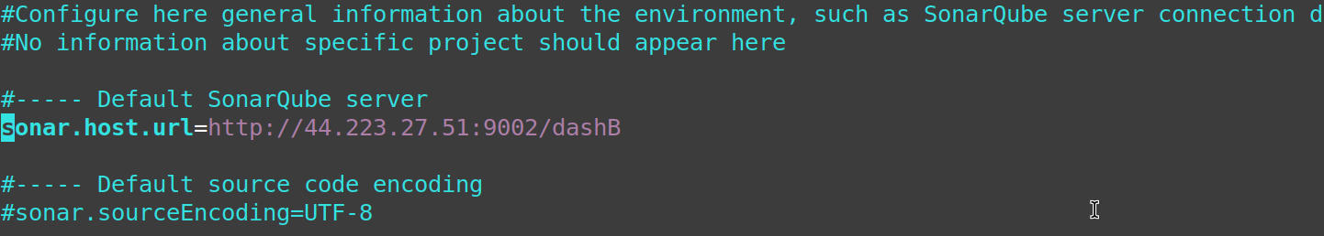Integration on cli

2.

DashB > Manage Jenkins > SonarQ Installations - Server URL chane port number > token change

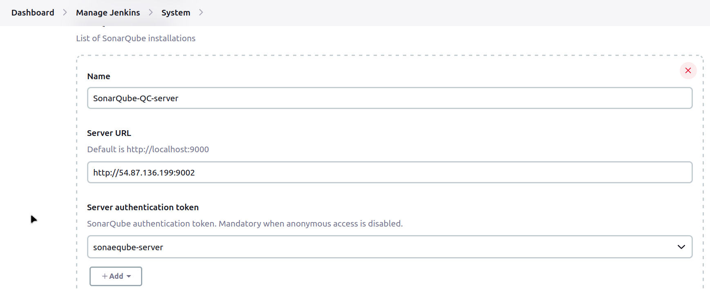Integration on GUI

3.

SonarQube Authentication Token generate for integration:

SonarQube new webpage > login > click on profile > My Account > Security Tab >

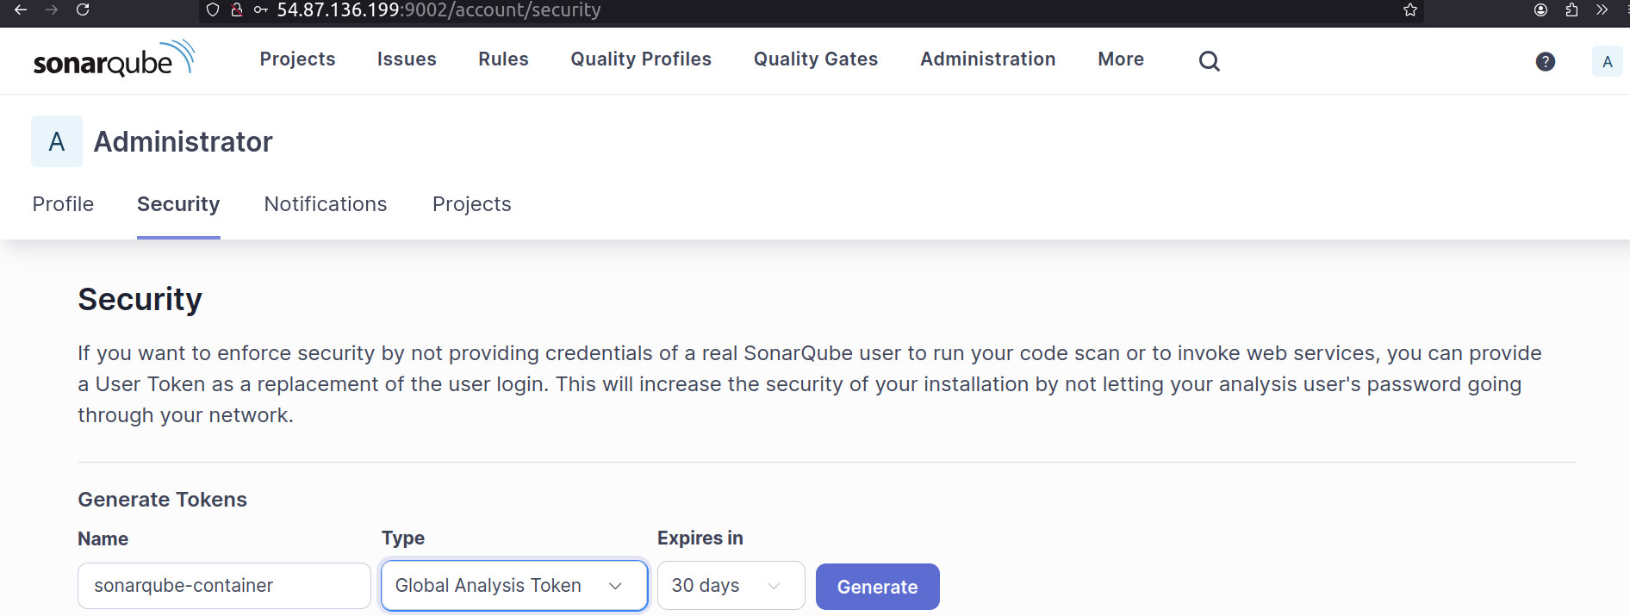  
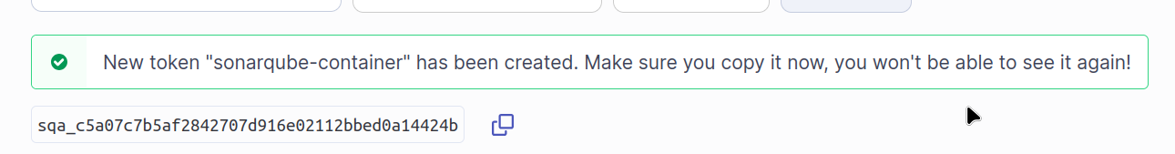  
Click on Add button below Server authenticatin token on Jenkins SonarQube Installation/configurations page

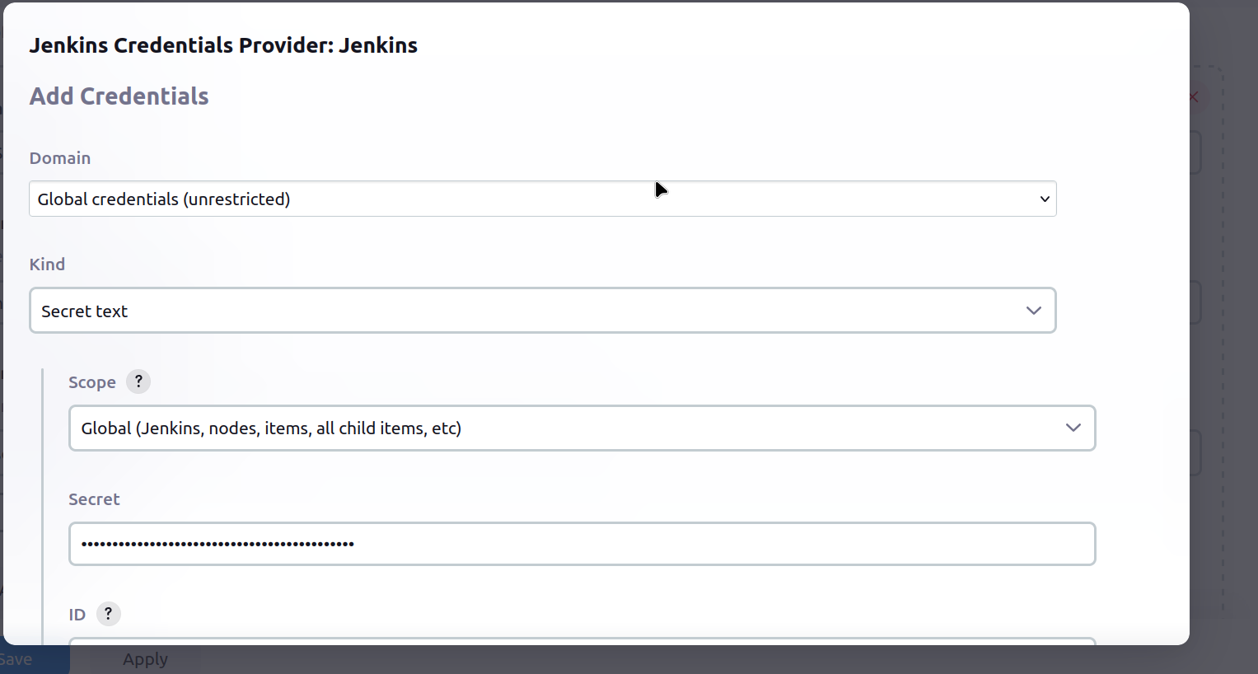  
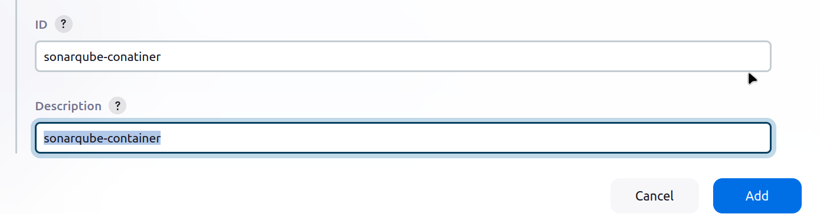  
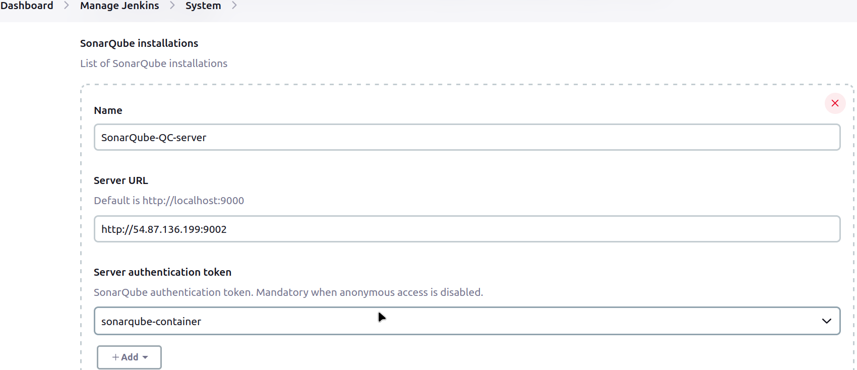Save

Execute the Job, Click on Build Now!

Change the creds key secret key under SystemSettings of Jenkins

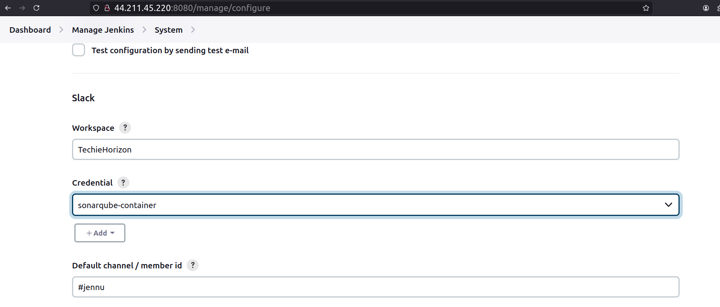  
If existing job/build is ebing used check for each and every configuration whether matches or not

If repo has been changed, check for type of brach

Error Doc:

For an unofficial reason SonarQube and Jenkins Servers running over AWS EC2 instance have to stopped, and when restarting after a while both the server restarted properly

To make sure of this, version of java jenkins were checked Jekins-master server and on SonarQube server database i.e mysqld service was checked and database configuration were cross-checked as well.

Since services on both servers were enabled, theywere up even after the reboot of the servers

However, while working for integrations of SonarScanner to SonarQube, SonarQube page was giving error, a general one

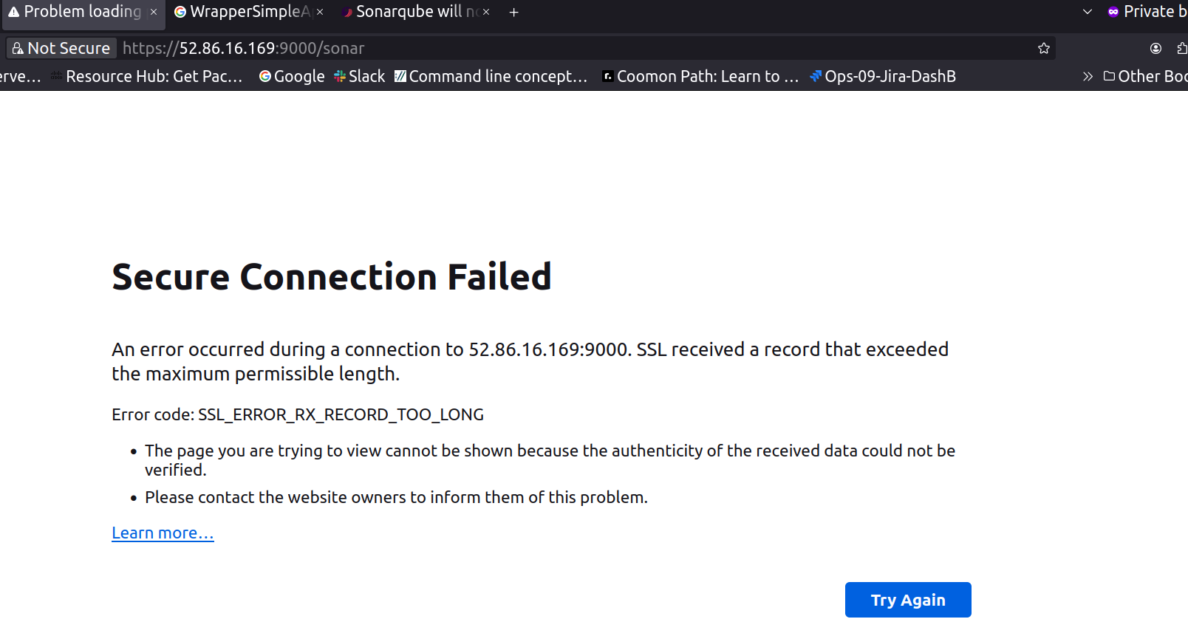

To solve and getback the webpage up and running, SonarQube service was restarted within no-time,

to avoid downtime

In rush to start the SonarQube service using script named ‘sonar.sh’ located in opt Sonarqube-qc bin linux86_64

the commands to start the script was ran as root user which initial started the service providing a sign of relief however, when the wepage was checked the error was still the same, whchi indicates issue still persist.

After refering the command locations, on terminal, service was started again status was checked immediately for a second or two service was up and again back down after 2-3 seconds

Logs were checked and error were found using those error lines as reference seach ops were initated

which ended with conclusion that the as the command to start the service was ran as root user, it created an issue and at the second attempt or first the log files/foldr were created asaresult of error inside the files/folder

# Sonar version 7 and higher cannot be run using root user,please switch to any other user and change the permissions to sonar directory and start sonar.

Opt sonarqube-qc temp directory with the

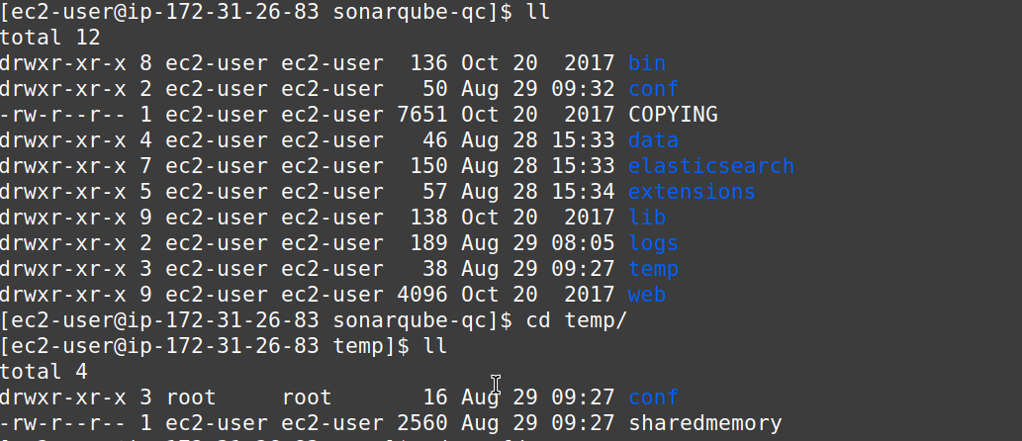  
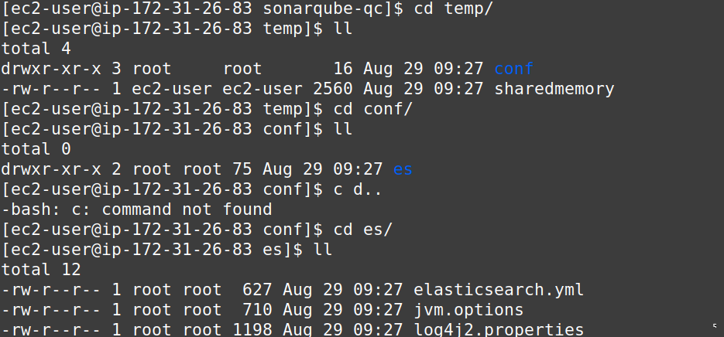

# [Sonarqube will not start due to elasticsearch being unable to write yml settings file?](https://community.sonarsource.com/t/sonarqube-will-not-start-due-to-elasticsearch-being-unable-to-write-yml-settings-file/15643)

A URL

the conf folder and its files have to be deleted which were under /opt/sonarqube/sonarqube-7.9.1/temp b

Because they were owned by root (probably from prior execution attempts).

I was able to hit the web page and all was looking good until it ran out of memory and stopped. I am guessing I need to configure something. Here’s the log:

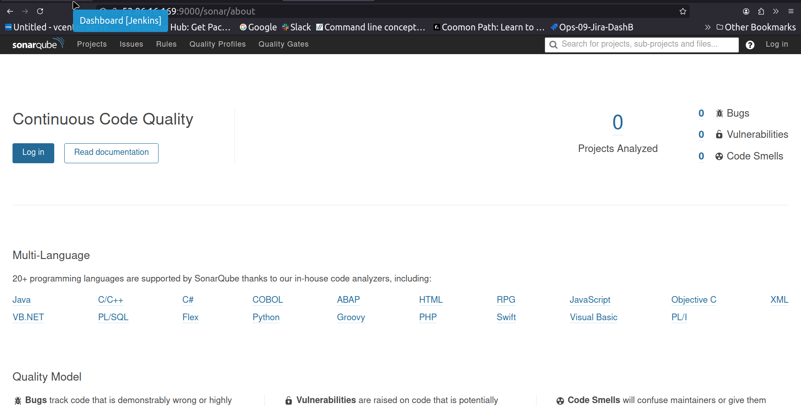

another error:

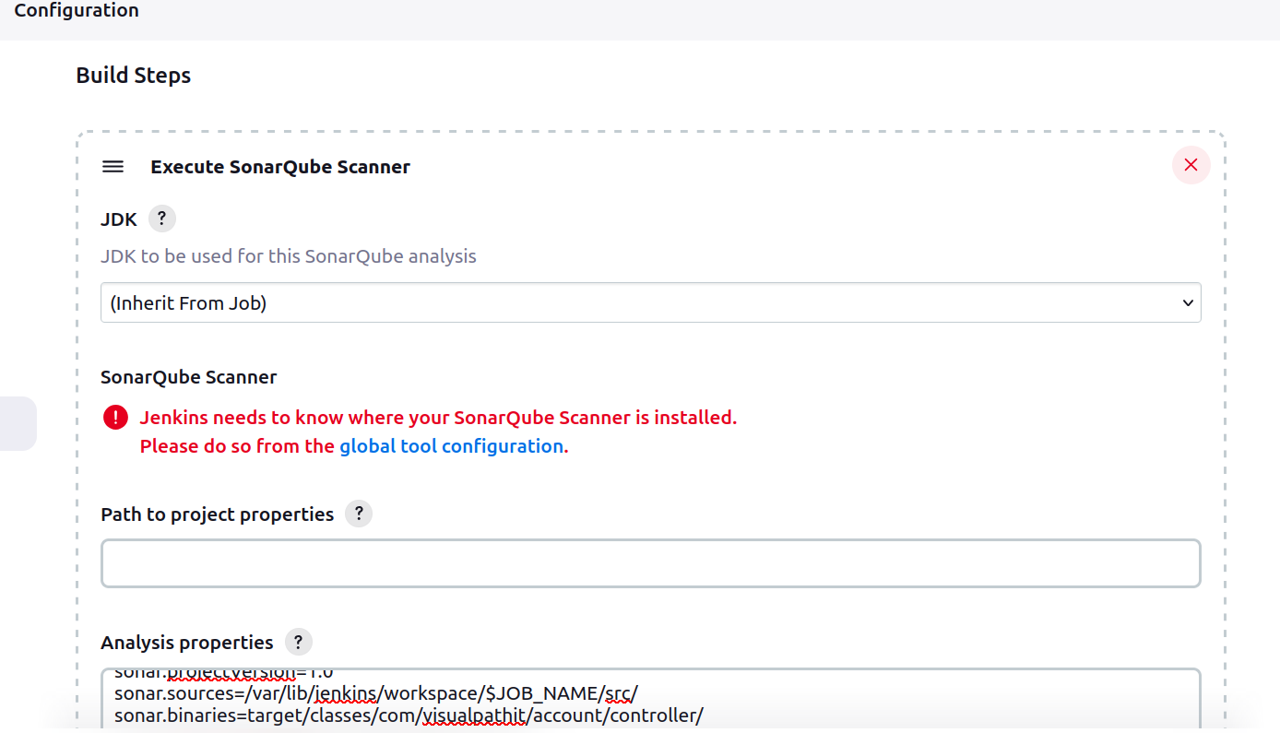

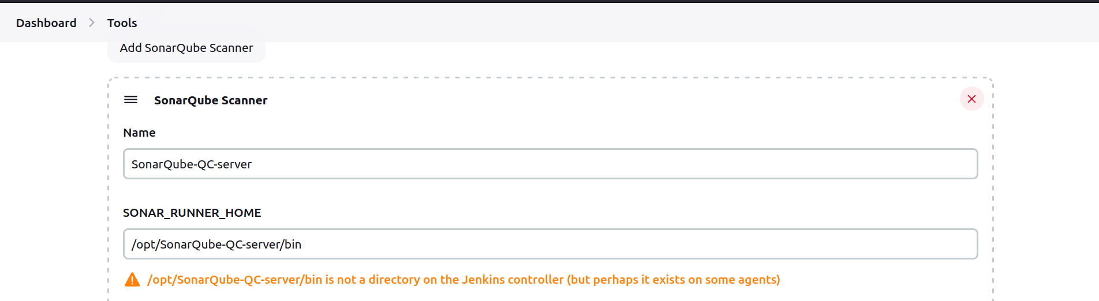

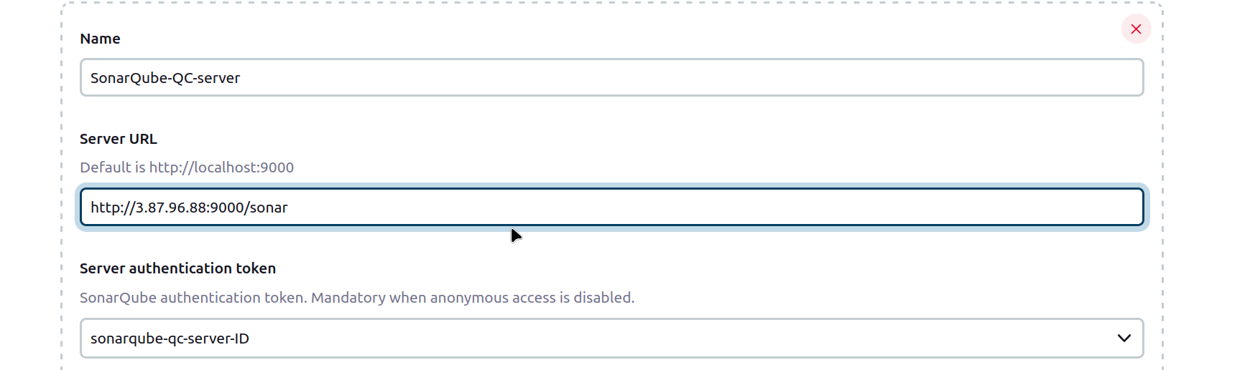  
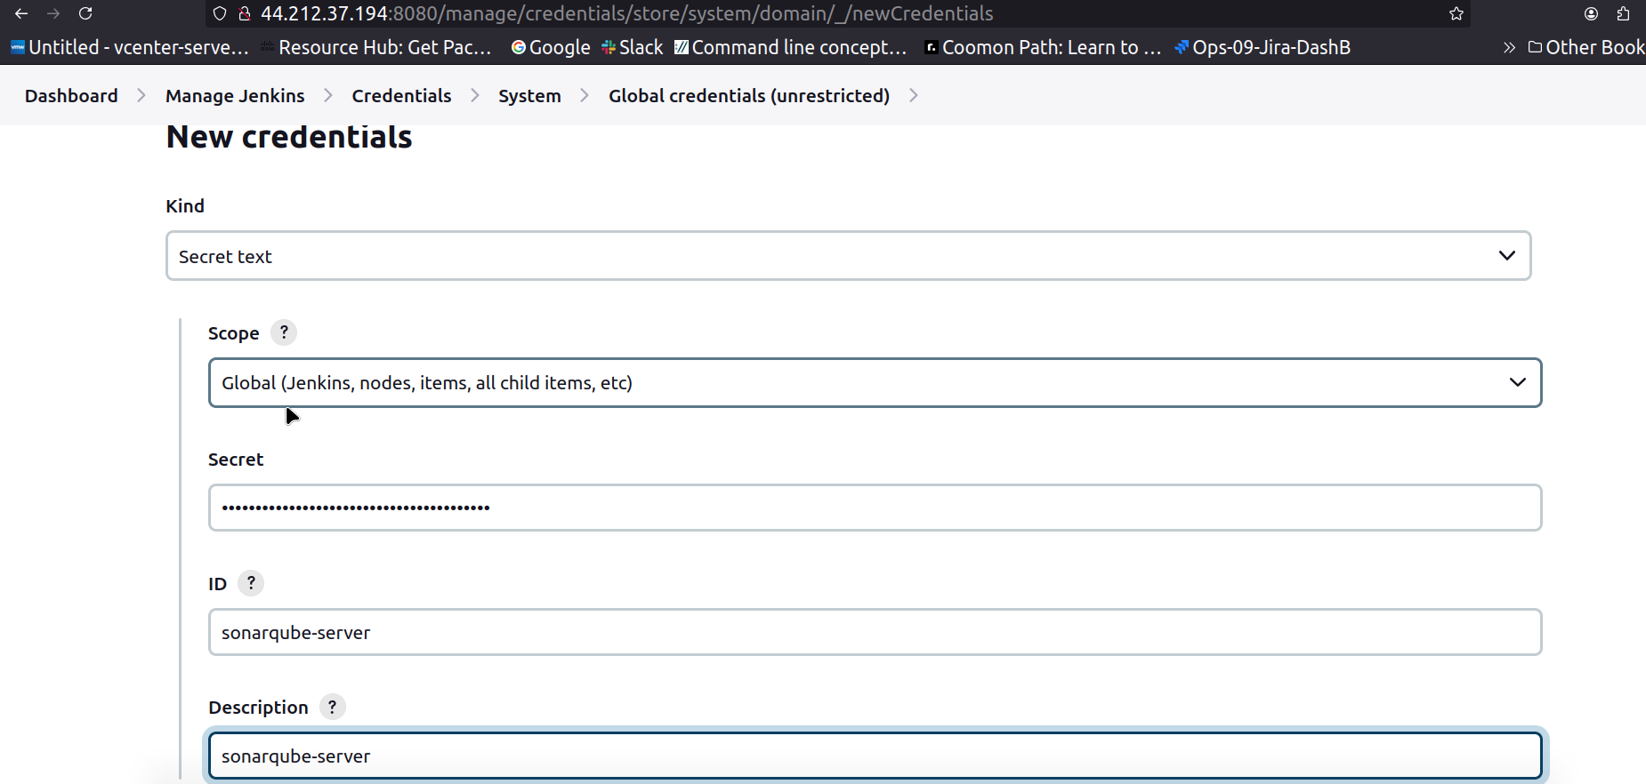

Error:   
when uninstalling a plug in if some issue occurs uninstallation goes pending, due to which Available Plugin option won’t show Slack plugin so it can’t be reinstalled, as it is not properly removed from jenkins.

In this case, go to jenkins server home/default directory remove /plugins search for plugin named slack or directory, remove it

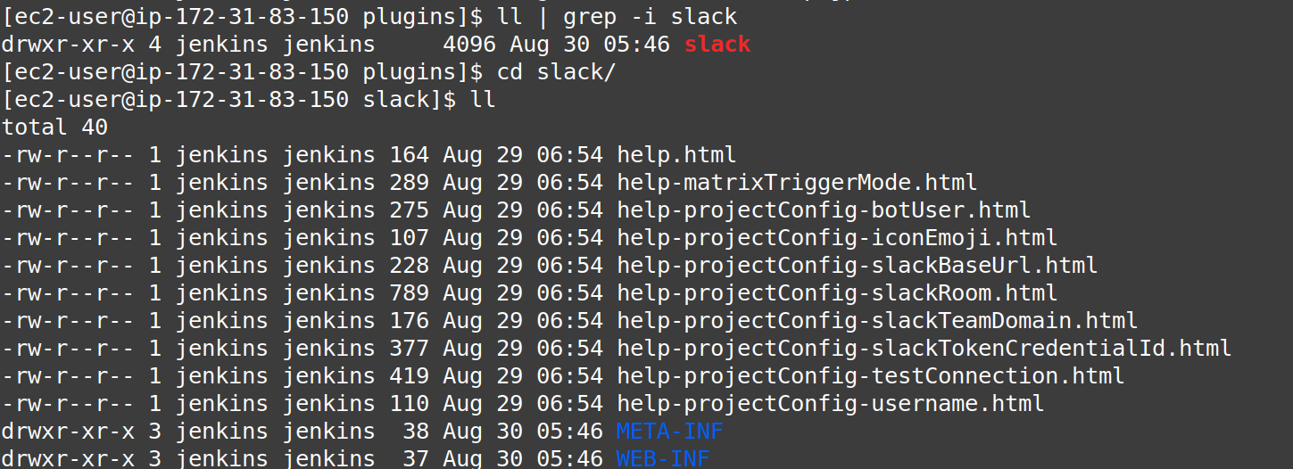  
  
then, slack plugin can be installed from GUI if not, restart the jenkins service or jenkins in worst case.

Refer particular which can be found from jenkins > plugin > link

<https://plugins.jenkins.io/slack/>

Click on how to install butto on top most left side of the screen

Other way using Jenkins Cli

to start using CLI create specific directory anywhere on jenkins server

DashB > Manage J > Jenkins CLI

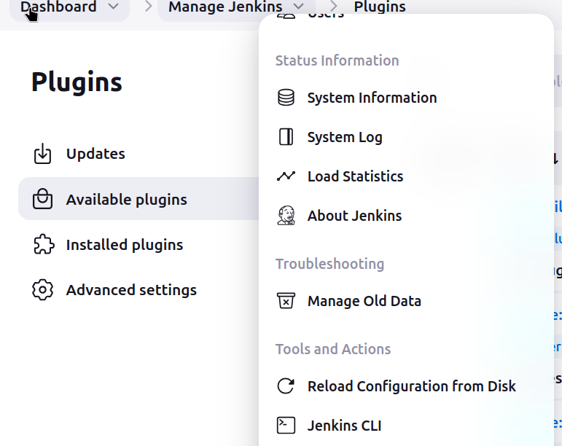

download [jenkins-cli.jar](http://54.172.187.200:8080/jnlpJars/jenkins-cli.jar), and run it as follows:

Wget <http://54.172.187.200:8080/jnlpJars/jenkins-cli.jar>

#java -jar [jenkins-cli.jar](http://54.172.187.200:8080/jnlpJars/jenkins-cli.jar) -s http://54.172.187.200:8080/ who-am-i

Notice: it didn’t ask for creds

#java -jar jenkins-cli.jar -s http://localhost:8080/ -auth Username:password who-am-i

to install plugin

#java -jar jenkins-cli.jar -s http://localhost:8080/ -auth username:password install-plugin serenity:1.4

serenity is the name of the plugin and 1.4 is the version of the plugin.

#java -jar jenkins-cli.jar -s http://localhost:8080/ -auth username:password safe-restart

To verify that the Serenity plugin is installed or not in Jenkins, please go to Manage Jenkins -> Plugin Manager ->Installed -> Serenity Plugin.

<https://qaautomation.expert/2023/10/12/how-to-install-plugins-from-jenkins-cli/>

incomplete..~~

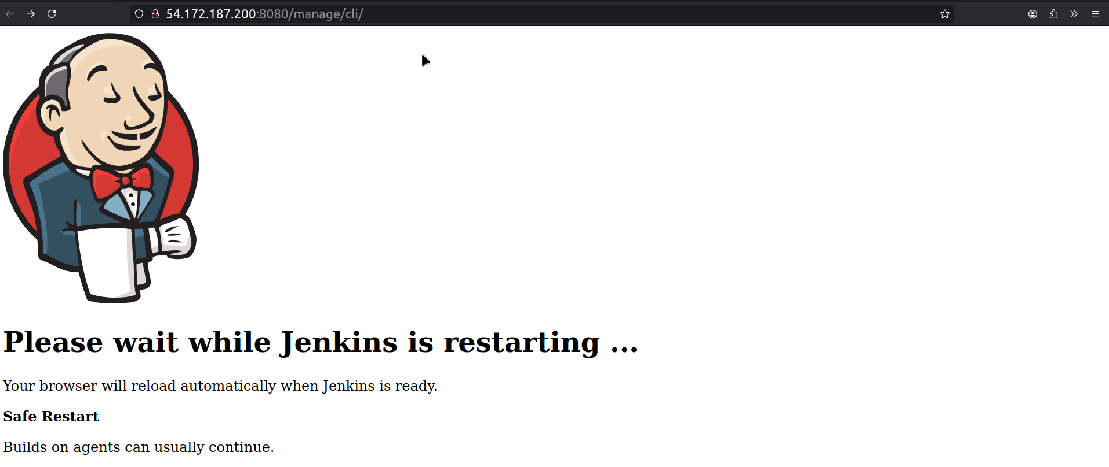  
there is an option to install after the restart on plugin page

On Jenkins :

jenkins.model.global.location.xml

cd opt sonar-scanner conf vi sonar.properties > add SonarQube servers IP address with port and pathprefix

-GUI

Manage Jenkins System configs > change SonarQubeIP:port

System > Server Authentication token -Cred > secret key > token no.

Manage J Tools > SonarQube Scanner > check path > incase of version mismatch try selecting Install Automatically; else both pages will still the job build won’t run because of version mismatch code won’t be analyised or checked for bug, code smells, vulns..

Build/Job > Configure > Git branch type > Analysis properties > Slack integration/Post-build integrations.

On SonarQube server :

cd opt sonar-qube-qc conf sonar.properties vi check 5 lines paramters

./sonar stop start console dump

Page load check

token no.

GUI

properties file ip port path prefix

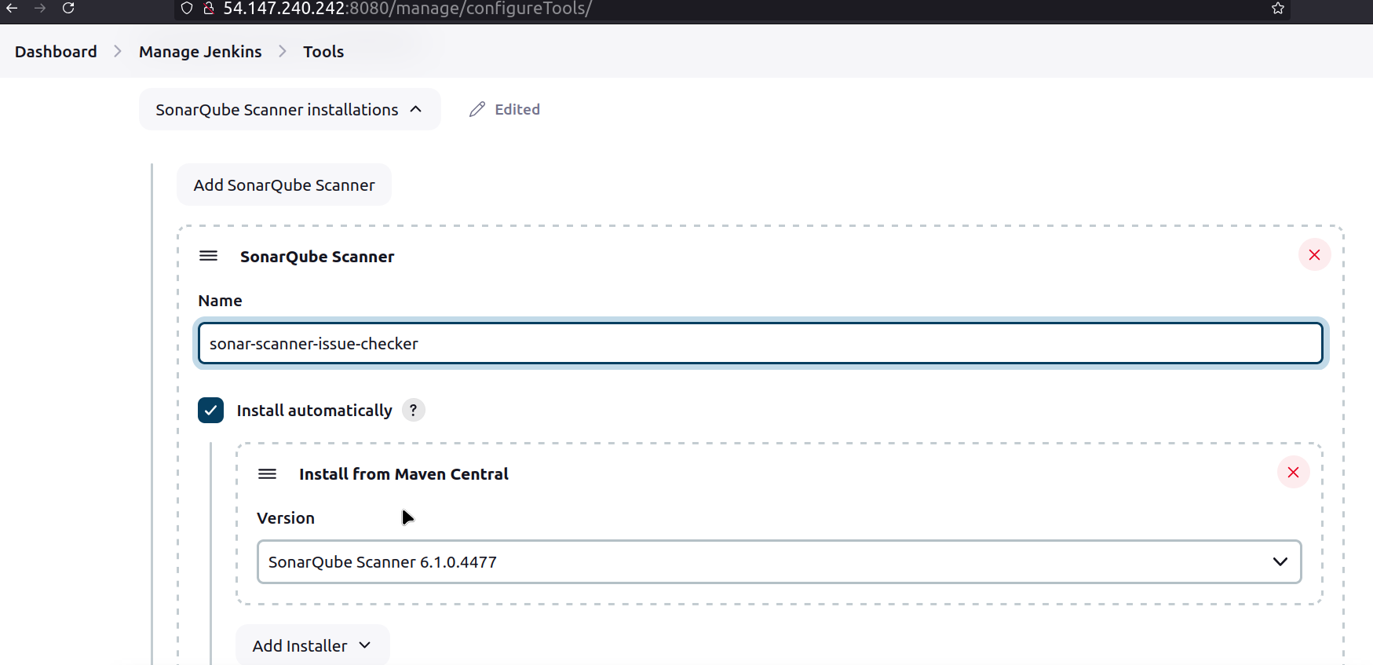  
Docker stopped or exited started it

chnaged the port image running on to 9003

as new image is being used creds changed, tocken generated, cred new secret text with it attached it to sonar integration configs #curl localhost:9003

#docker images

#systemctl start docker  
docker ps -a

sudo docker run -itd -p 9003:9000 sonarqube

docker ps -a #curl localhost:9003 #curl publicIP:port

sometimes chown -R ec2-user:ec2-user sonarqube-qc

manage Jenkins > Tools > remove manual entry > select Install Automatocally > select version > Install Maven option > Sonar Scanner version ending with 2966 >

Check Output

INFO: SonarScanner 4.6.0.2311

INFO: Java 11.0.23 Red Hat, Inc. (64-bit)

INFO: Linux 5.10.223-212.873.amzn2.x86_64 amd64

INFO: ------------------------------------------------------------------------

INFO: EXECUTION FAILURE

INFO: ------------------------------------------------------------------------

ERROR: Error during SonarScanner execution

java.lang.UnsupportedClassVersionError: org/sonar/batch/bootstrapper/EnvironmentInformation has been compiled by a more recent version of the Java Runtime (class file version 61.0), this version of the Java Runtime only recognizes class file versions up to 55.0

at java.base/java.lang.ClassLoader.defineClass1(Native Method)

ERROR:

ERROR: Re-run SonarScanner using the -X switch to enable full debug logging.

ERROR: SonarQube scanner exited with non-zero code: 1

[Slack Notifications] found #44 as previous completed, non-aborted build

Finished: FAILURE

Check here it says “Re-run SonarScanner using the -X switch to enable full debug logging.”

Goto Master-Jenkins Server

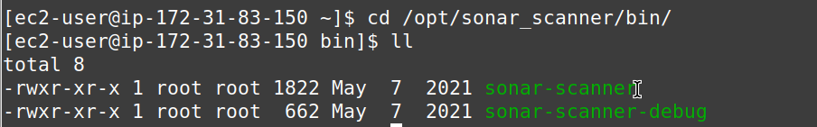

Run this script, it will show the actual/exact error

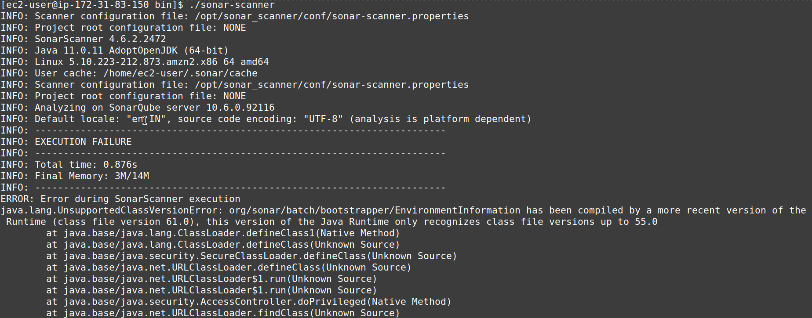  
Again here it show the same error to debug with -X

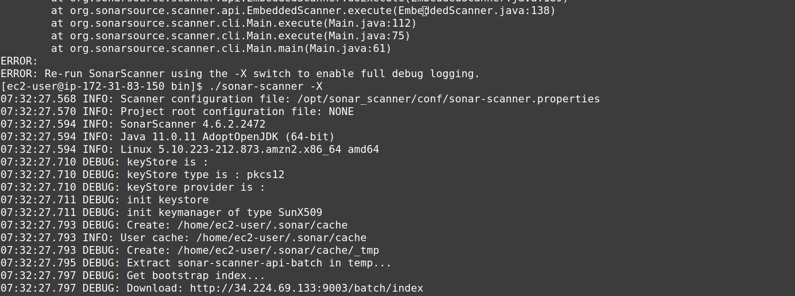

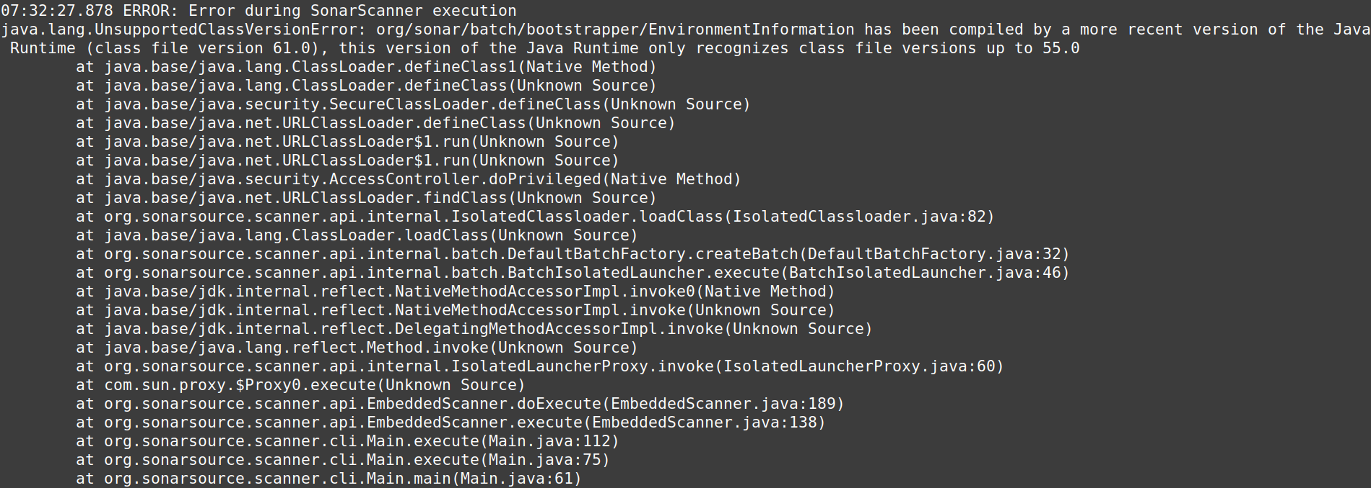

the debug error is eliminated, now the output says the error occured during SonarScanner execution

java lang unsupported class version error:

check java version being used and the sonar Scanner supports what all version, if doesn’t match,

java version have to be changed

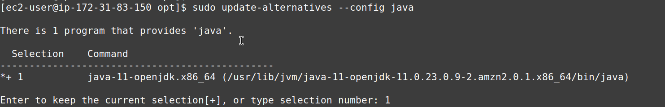  
Only a single version of java is running, check for supported version of java download install switch to the particular supported version

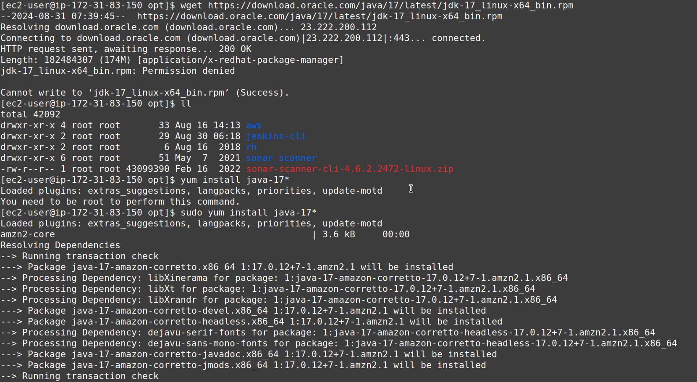

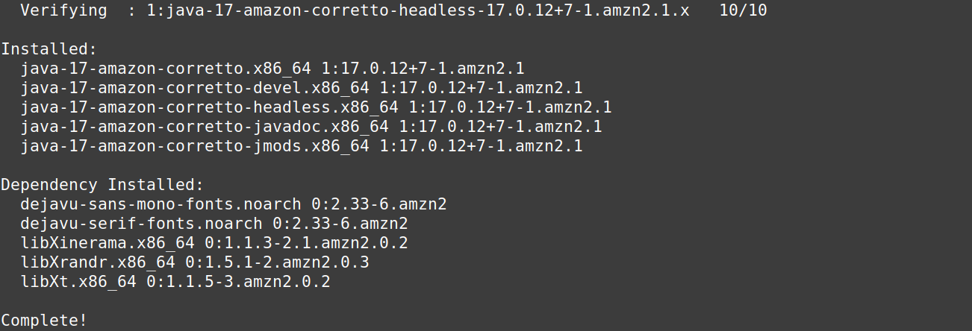  
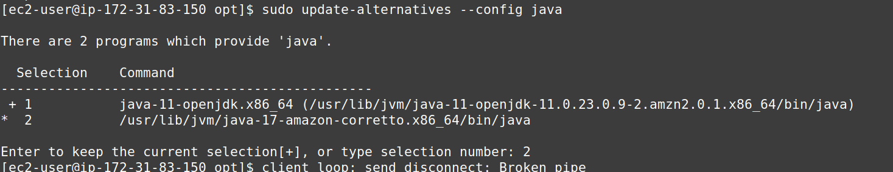  
Switch java version and Run Job/Build in Jenkins webpage

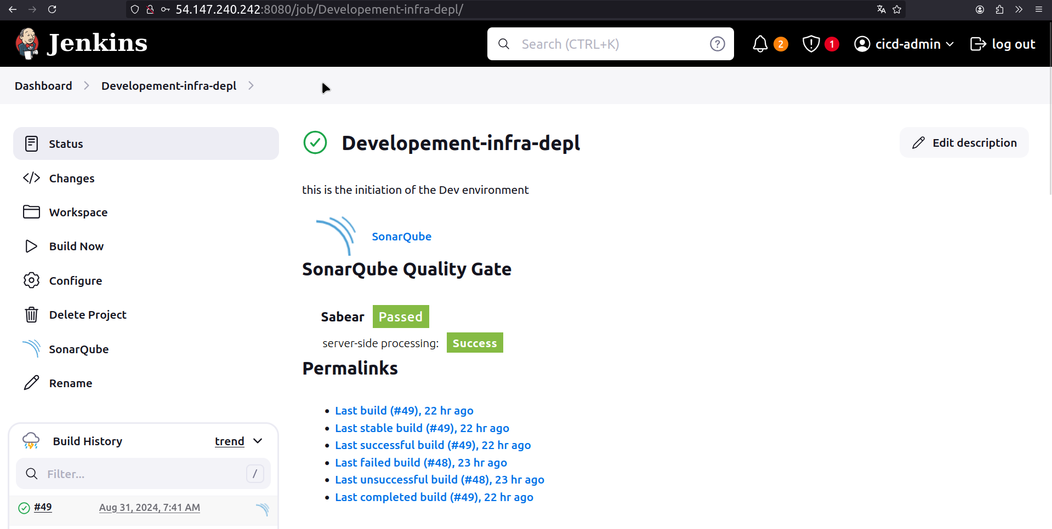

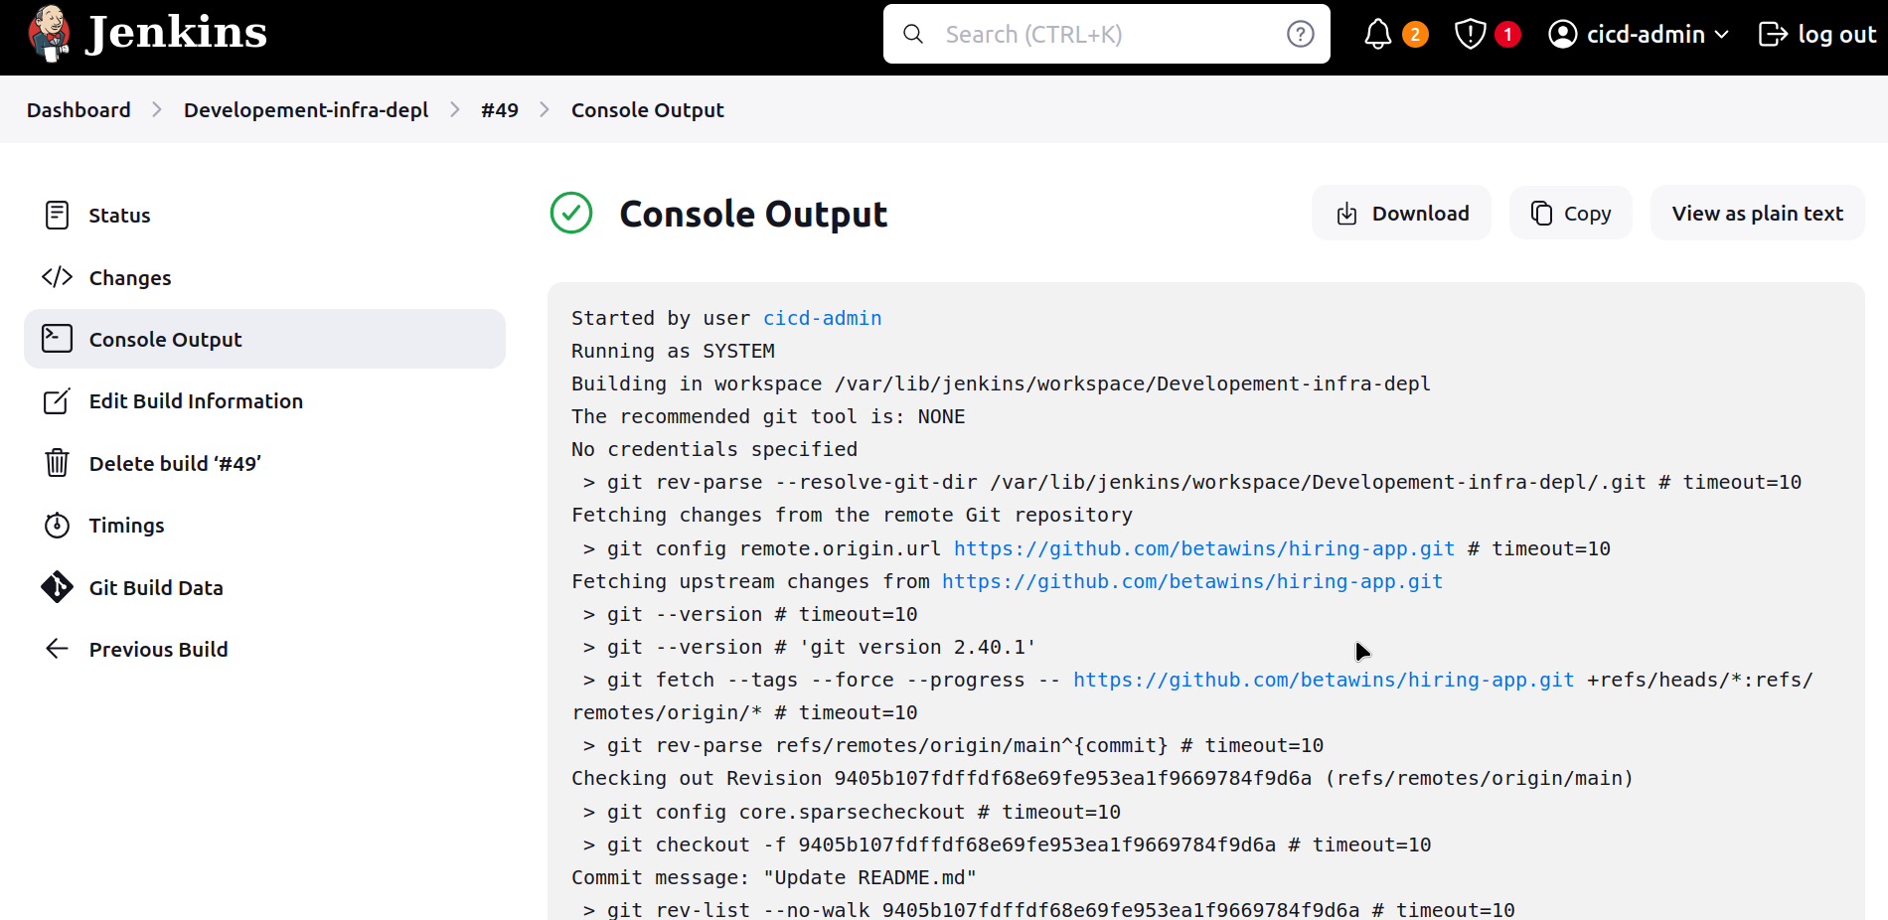

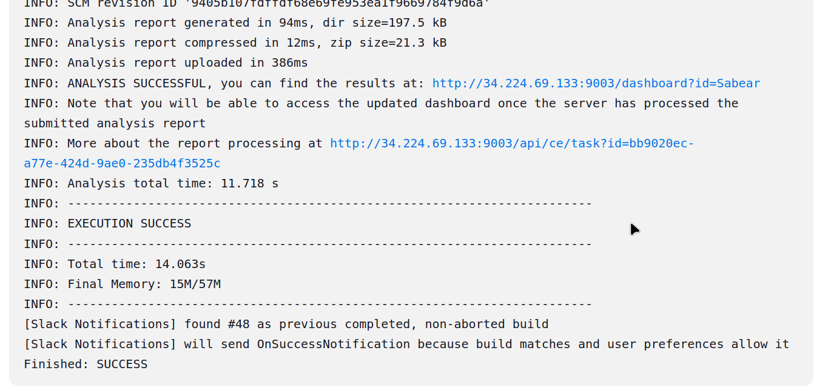  
SonarQube:

Access SonarQ webpage goto projects

Check the report of code analysis of

